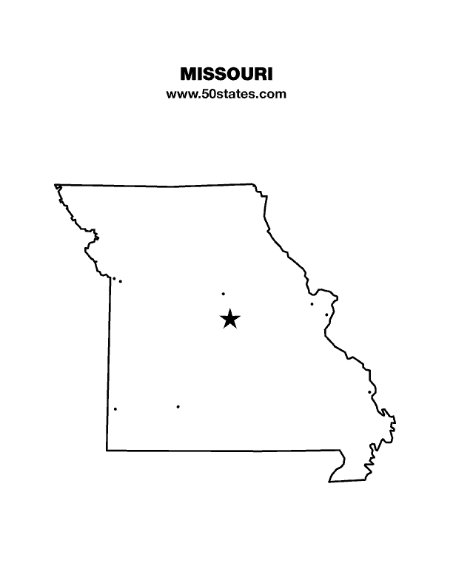**The Blind Missourian**

**January 2025**

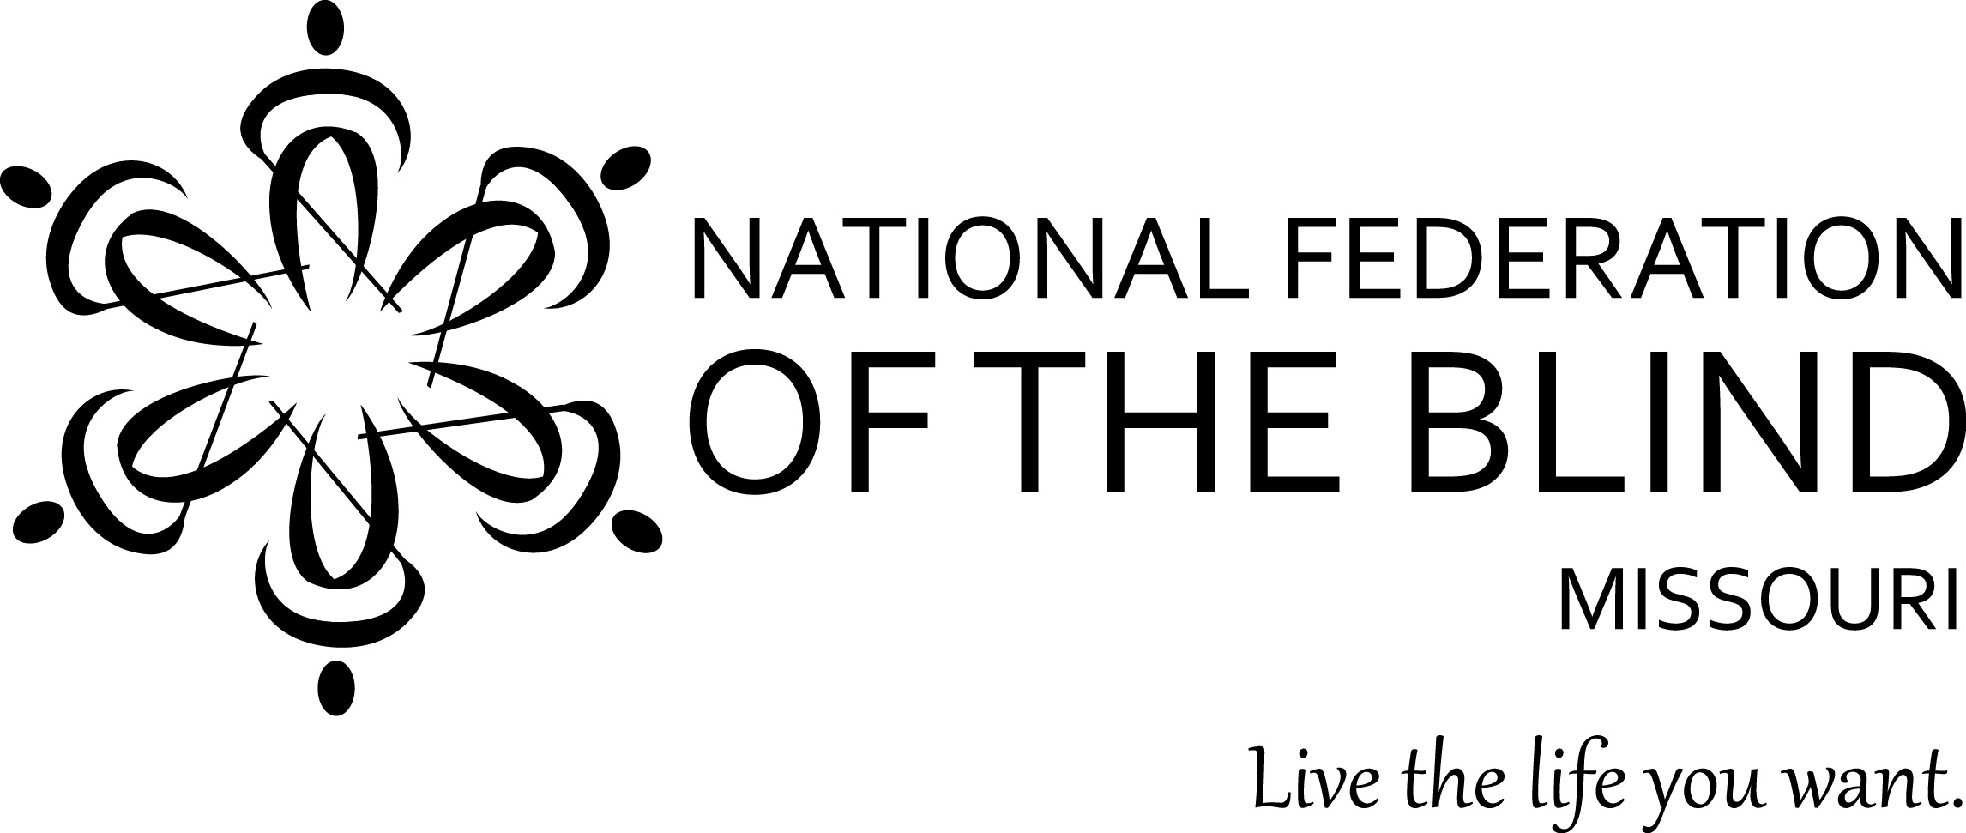

Table of Contents

Resolutions Passed at the 2024 State Convention 1

Saying Hello to Old Friends and Welcoming

New Ones by Debbie Wunder 5

2025 State Convention Packet by Eugene Coulter 6

2025 Scholarship Announcement by Robin House 10

2025 Chapter Elections 11

Pledge of the

National Federation of the Blind

I pledge to participate actively in the efforts of the National Federation of the Blind to achieve equality, opportunity, and security for the blind; to support the policies and programs of the Federation; and to abide by its Constitution.

The Belief Message

The National Federation of the Blind advances the lives of its members and all blind people in the United States. We know that blindness is not the characteristic that defines you or your future. Every day we raise the expectations of blind people, because low expectations create obstacles between blind people and our dreams. Our collective power, determination, and diversity achieve the aspirations of all blind people.

Hello everyone. It has been awhile since the last Blind Missourian and with the new year I hope to get back on track with two issues a year, but I am going to need your help. I am going to need lots of articles. Let’s make our New Years’s resolution to put out the best newsletter around!

The following resolutions were passed at the National Federation of the Blind of Missouri 2024 state convention.

Resolution 24.01

A Resolution Regarding Refreshable Braille Displays for Missourians

by Dennis Miller

WHEREAS, the National Library Service for the Blind and Print Disabled (NLS) is distributing refreshable Braille display units to regional network libraries for distribution to their patrons; and

WHEREAS, the Zoomax Braille display is one of two models the NLS is distributing to regional libraries; and

WHEREAS, there have been numerous complaints from patrons who have received the Zoomax Braille display which include a constant squealing sound that varies in pitch whenever the unit is turned on, as well as unacceptable delays when advancing to the next line of text; and

WHEREAS, the HumanWare model that NLS is distributing appears to be much more fluid in its overall operation, which is not surprising given the experience HumanWare has had in the integration of Braille hardware and software: Now, therefore,

BE IT RESOLVED that the National Federation of the Blind of Missouri in Convention assembled this 14th day of April, 2024, in the City of Kansas City, Missouri, we strongly encourage the National Library Service for the Blind and Print Disabled to end the practice of distributing the Zoomax Braille display, at least until the unit can be modernized with faster and better technology; and

BE IT FURTHER RESOLVED that Missourians, like those from other states who have trouble with the Zoomax display, be given a HumanWare unit based on its responsiveness and reliability.

Resolution 24.02

A Resolution regarding Continuous Glucose Monitors and Their Use by Blind People

WHEREAS, Continuous Glucose Monitors (CGMs) are crucial for the effective management of diabetes, significantly reducing the need for fingerstick blood tests, which are particularly invasive for blind people who rely on their tactile sense for reading Braille and performing other tasks; and

WHEREAS, the majority of CGMs come with reader devices that are not accessible to blind people, as these devices provide output solely in a visual format, thereby excluding blind people from independently monitoring their blood glucose levels; and

WHEREAS, Medicare mandates the purchase of a reader device before approving sensor coverage, placing a financial burden on blind people who cannot use these readers, forcing them to seek alternative, often less accessible means to access their CGM data; and

WHEREAS, Medicare's policy of allowing the replacement or upgrade of CGM devices only once every five years limits access to technological advancements that could offer significant health management improvements for people with diabetes, particularly affecting those who are blind; and

WHEREAS, the reliance on smartphone technology for accessing CGM data, while beneficial for some, excludes those who cannot afford such technology or lack the skills to use it, further limiting the independence of blind people in managing their diabetes; and

WHEREAS, the resolution of these issues requires the attention and action of several entities, including CGM manufacturers, Medicare, private insurance companies, and regulatory bodies; Now, therefore:

BE IT RESOLVED that the National Federation of the Blind of Missouri, in Convention assembled this thirteenth day of April, 2024, in the City of Kansas City, Missouri, urges manufacturers of CGM devices to prioritize the development of reader devices accessible to blind and low-vision people, ensuring these essential health management tools are usable by all who need them; and

BE IT FURTHER RESOLVED that the National Federation of the Blind of Missouri calls upon Medicare to reevaluate its policies regarding the upgrade and replacement of medical devices such as CGMs, to ensure that technological advancements are accessible to beneficiaries, particularly those with vision loss, based on functional improvements rather than arbitrary time constraints; and

BE IT FURTHER RESOLVED that this resolution be forwarded to relevant authorities, including Medicare, the Food and Drug Administration (FDA), the National Association of Insurance Commissioners (NAIC), and the Centers for Disease Control and Prevention (CDC), to advocate for policy changes that reflect the needs of blind people; and

BE IT FINALLY RESOLVED that this resolution be sent to our national Resolutions Committee for consideration at our 2024 National Convention.

Resolution 24.03

A Resolution on Enhancing Self-Checkout Accessibility for Blind People

WHEREAS, self-checkout technology is proliferating across major retailers like Walmart, Target, and Kroger, offering speed and convenience to shoppers; and

WHEREAS, the current design of many self-checkout systems, relying on visual interfaces and touchscreens without audible instructions or tactile feedback, poses significant accessibility barriers to blind people; and

WHEREAS, the reliance on barcode scanning exacerbates these challenges, further impeding the ability of blind people to use these systems independently; and

WHEREAS, the reduction of human cashier options in favor of self-checkout systems limits the accessibility of shopping environments for blind people, compromising their independence and right to equal service; and

WHEREAS, adherence to the principles of inclusivity, equality, and the legal obligations under the Americans with Disabilities Act necessitates that retail services be accessible to all customers, including those who are blind: NOW, Therefore

BE IT RESOLVED, that the National Federation of the Blind of Missouri, convening in Kansas City, Missouri, on April 13, 2024, demands that Walmart, Target, Kroger, and similar retailers Implement self-checkout options that are accessible to blind people, including but not limited to voice-guided instructions, tactile buttons, and interfaces designed for ease of use; and

BE IT FURTHER RESOLVED that these retailers Ensure the availability of human cashiers in sufficient numbers to meet the needs of all customers, including those unable to use self-checkout stations due to blindness; and

BE IT FURTHER RESOLVED that these entities collaborate with the National Federation of the Blind to understand the needs of the blind and work on developing accessible solutions; and

BE IT FINALLY RESOLVED that all retailers provide staff with ongoing training focused on the accessibility needs of blind customers, including assistance at self-checkout stations and throughout the store.

Resolution 24.04

A Resolution Concerning the Name "Frugal Federationist"

WHEREAS, the National Federation of the Blind of Missouri has historically and proudly used the name "Frugal Federationist" to embody principles of economic efficiency and identity within the Federation; and

WHEREAS, the name "Frugal Federationist" is not only memorable but also carries significant meaning through its alliteration and the clarity of the terms used, effectively representing the value the Federation holds in saving its members money and offering even greater value; and

WHEREAS, the recent decision to abandon the name "Frugal Federationist" in favor of a new, yet notably less memorable and impactful name, has caused confusion and a sense of loss among the members of the Jefferson City chapter; and

WHEREAS, the clarity and alliterative charm of the original name "Frugal Federationist" significantly contribute to the identity and branding of the Federation, making it a valuable asset for communication and member engagement: NOW, THEREFORE:

BE IT RESOLVED that the National Federation of the Blind of Missouri’s Jefferson City Chapter strongly urges the reconsideration of the name change from "Frugal Federationist" to the new, easily forgettable name; and

BE IT FURTHER RESOLVED that the Jefferson City Chapter of the National Federation of the Blind of Missouri respectfully requests the restoration of the original name "Frugal Federationist," highlighting its ease of recall, alliteration, and the clear representation of the Federation's values; and

BE IT FURTHER RESOLVED that this resolution is presented with the hope that the convention will accept it with the levity intended and grant it whatever weight the convention sees fit in terms of the name we use to extend bargains to our fellow Federationists.

Saying Hello to Old Friends and Welcoming New Ones

By Debbie Wunder

On September 29, 2024, the Jefferson City Chapter, the Columbia Chapter, and the National Federation of the Blind of Missouri Membership Committee sponsored a picnic to do just what the title says. I cannot remember any kind of joint sponsorship like this, but it worked and what a fun day it was.

Thanks to the Columbia Chapter for booking us such fine accommodations. We had good food, with the Jefferson City Chapter providing the meat and contributions from all members who came from around the state bringing the fixings. The Membership Committee brought fun games, including Corn Hole. Several of us learned it isn't as easy as it sounds to win.

We had two cooks this year. Lawrence Luck has long been our grill master in Columbia; and he was joined this year by Abbey Houchen, my youngest daughter. Luckily, we purchased enough meat and got enough other food that no one went away hungry.

More important than the food or the games, we got to visit with longtime Federationists and people who made it clear they may be interested in joining us. The four chapters in attendance were: Jefferson City, Columbia, Springfield, and Lewis and Clark. We could not have asked for a more congenial group and God helped us tremendously with a day that couldn't have been better if we requested it directly.

Thank you to all who helped plan and who attended the picnic. I believe we will get some new members and I know we are all better off for the time we spent together. It will be one of the more memorable Sunday afternoons of my year, and I hope many of you feel the same.

63rd Annual Convention of the National Federation of the Blind of Missouri

Stoney Creek Hotel 2601 S. Providence Rd, Columbia, MO 65203

Phone: 573-442-6400

April 10-13, 2025

pre-register online at www.nfbmo.org

The Columbia Chapter would like to warmly welcome you to Columbia for our 63rd annual convention. Columbia is proud to be the home of a major insurance company, three universities and is the major health care hub for Central Missouri. Columbia has been the home of many entertainers from the blind ragtime pianist James William “Blind” Boone, Jane Froman, Cheryl Crow, Dawn Wells, and Brad Pitt, among others.

Come to the Stoney Creek Hotel with room rates of $99 a night (plus 12.975% tax). To make reservations, call 573-442-6400 and use code 25NFBLAC before March 20. The hotel is pet friendly and has a fitness center, free Wi-Fi, and an indoor/outdoor pool. check-in is at 3:00 PM and check-out is at noon. The hotel features the Antlers lounge bar. The hotel’s web page is StoneyCreekhotels.com.

Once again, we have the Frugal Federationist© Package for $85 if bought by April 1. This includes registration, a banquet ticket, and a Saturday lunch ticket, saving you up to $35. Be sure to make your choice between Baked chicken and steak for the banquet when you register. We will also have a planned lunch for Friday. After April 1, the cost for registration and all meals will increase by $5 each. There will be opportunities to register and pick up packets on Friday and early on Saturday. Hospitality will be open on Friday evening.

We will be offering the Kid’s Zone for children in need of supervised care. There is no cost for children who are registered for the convention. See the information on the following pages for details on Kid’s Zone, children’s meal prices, and exhibitor/sponsorships. To donate door prizes, please contact co-Chairs Brittany Berk and Grace Warn. Grace’s email address is gwarn84@gmail.com. Those bringing door prices should drop them off at the registration table.

Important Notes:

•All attendees should refrain from wearing perfume or cologne or using scented lotions during convention sessions as these can trigger health problems for others in attendance including allergies or asthma issues.

•All attendees are required to adhere to Our Code of Conduct, and we will abide by all government issued Covid protocols.

National Federation of the Blind of Missouri

63rd Annual Convention, April 10-13, 2025

Please use one form per residence. Several registrations may be combined on one order if they are sent together. Sorry No refunds unless the event is cancelled.

First Registrant’s Name: ___________________________________________

Second Registrant’s Name: _______________________________________

Street Address: __________________________, Apt.: ________

City: ______________________, State: ____, Zip Code: _________

Phone Number: ______________, Email: _____________________

Select preferred agenda format: Braille ___ Print ___ Email ___

Do you require an assisted listening device, or do you have other accessibility needs? Specify here: __________________________________________.

Frugal Federationist Package: only available until April 1, 2025, Includes registration, banquet, and Saturday lunch.

Number of Baked Chicken packages for banquet ___ at $85.00 $_______

Number of steak packages for banquet ____ at $85.00 $_______

***After April 1, 2025, please add $5 for each item below.

Friday Lunch: number needed _______ at $25.00 Total: $______

Convention Registrations in addition to Frugal package ___at 25.00 $_______

Baked Chicken banquet in addition to package _______ at 55.00 $_______

Steak banquet in addition to package _______ at 55.00 $_______

Saturday lunch in addition to Frugal package _________ at 25.00 $_______

Total amount enclosed: $______

Send payment made out to NFB of MO to: Carol Coulter,

1504 Furlong Drive, Columbia, MO 65202.

National Federation of the Blind of Missouri Convention

Children’s Registration Form and Kid’s Zone Request April 12-14, 2025

We will be offering childcare for those children of parents who are registered for the convention in need of supervised care. There is no additional cost for children who are registered for the convention, see the form below to register. Care will be provided during all general sessions and the evening banquet until 9:00 PM. Meals are not provided in the Kid’s Zone, so parents need to feed their children.

Important: Parents wanting to care for their children must send this request along with payment for registration and meals on or before March 11, 2025. Mail it along with payment to the address below. Note: for children NOT needing childcare, payments for pre-registration and meals must be received by April 1. Payments can be mailed or made at www.nfbmo.org. Meals and registration purchased after April 1, 2025, will cost an additional $5.00 each.

Name of Parent or Guardian: _____________________

Address: ________________________________________

City, State, Zip: ________________________________

Cell Phone: _______________ Home Phone: ________________

Names and Ages of Children: ___________________

Special Concerns: __________________________________________________________________Are the above-named children in need of services in the Kid’s Zone? _____

Number of registrants: ___ at $10.00 Total: $______

Annual Child’s Banquet: ____ tickets needed at $30.00 Total: $______

Friday Lunch: ________ tickets needed at $12.50 Total: $______

Saturday Lunch: ______ tickets needed at $12.50 Total: $______

Total amount enclosed: $______

Send payments made out to NFB of Missouri to: Carol Coulter

1504 Furlong Drive, Columbia MO 65202.

National Federation of the Blind of Missouri Convention

Sponsorship and Exhibitor Registration April 11, 2025

We are pleased to offer the opportunity for companies and organizations to either exhibit or sponsor our 2025 convention. This year we will be at the Stoney Creek Inn 2601 S. Providence Rd Columbia, MO. from April 10-13. Exhibits will be open on Friday, April 11 from 1:00 PM to 9:00 PM. Below is the registration form including information on sponsorships. Space is limited and is offered on a space available basis with the deadline to submit payment and from April 1 providing there are remaining spots.

Name of Organization: _____________________ Phone: __________________

Contact person: _______________________ Email: ___________________

Address: _____________________________________________

Items exhibiting: __________________ ___________________

Exhibits:

•____ $50 for exhibit table only

•____ fee waved NFB Chapter or division exhibit

Sponsorships:

•____ Bronze $100 includes exhibit table, 25-word informational message in agenda, and a mention on the www.nfbmo.org State Convention Page until April 30, 2025.

•____ Silver $250 includes exhibit table, 60-word informational message in agenda, a thank you at opening ceremony and banquet, and a mention on the www.nfbmo.org State Convention Page until April 30, 2025.

•____ Gold $500 includes exhibit table, 100-word informational message in agenda, a thank you at opening ceremony and banquet, and a mention on the www.nfbmo.org Home Page and State Convention Page until April 30, 2025.

•____Diamond $1,000 same as Gold plus a one-hour showcase Friday morning and the ability to include your company logo on the NFBMO.org website until April 30, 2025.

Make checks payable to NFB of Missouri and mail them to: Carol Coulter, Treasurer 1504 Furlong Drive, Columbia, MO 65202.

Date: November 15, 2024

To: Missouri Students

Subject: Scholarship Opportunities

The National Federation of the Blind of Missouri announces our

2025 Scholarship Program. We will be accepting applications until February 15, 2025. We invite all qualified candidates to apply. Applicants must be legally blind and plan to enroll in a post-secondary institution for the fall of 2025. Applicants should live in Missouri but need not be a member of the National Federation of the Blind. Scholarships begin at $750 and are based on merit. Applicants are invited to submit all information and documents online. All application materials must be received by February 15, 2025, by using the direct link below for the application and by emailing documents to Scholarships@nfbmo.org. This announcement is also available on our website at www.nfbmo.org. Acknowledgment of applications and documents will be sent upon receipt. If you have questions or concerns, please do not hesitate to contact the Scholarship Chair.

Scholarship Application Checklist

* Official application form
* Proof of legal blindness
* Student essay
* Student transcripts
* Two letters of recommendation
* A letter from an NFB of Missouri Scholarship Committee member. Contact the Scholarship Chair to arrange this interview once you complete the first 5 requirements.

Please note:

* Letters of recommendation must not be submitted by the applicant but must come directly from the person authoring the letter.

* In an effective essay the applicant may consider sharing about their life in a way that gives the committee insight into who they are. The essay should cover the ways in which one lives successfully as a blind person and describe personal goals for the future. Committee members give the essay a great deal of attention.

* In addition to receiving the monetary award, the scholarship Finalist will attend the convention of the National Federation of the Blind of Missouri, April 11-13, 2025, at Stoney Creek Hotel, 2601 S Providence, Columbia, MO, 65203. Accommodation, convention registration, and planned meals during the convention will be provided. We are also happy to help coordinate transportation to ensure this is not a barrier to our scholarship class. The type of transportation assistance may vary based on where in Missouri the finalist resides and the available transportation resources in that community.

* Throughout the convention, scholarship finalist will have an opportunity to experience the National Federation of the Blind and network with successful blind people. In addition, final interviews with the Scholarship Committee will aid the committee in determining the scholarship each finalist will receive.

* You should know that merit scholarships from the National Federation of the Blind go directly to the winner. Therefore, students can use funds to meet expenses that other funding sources do not cover. Also, merit scholarships are viewed favorably when included on a resume.

The link to the application is available at the bottom of this announcement and on the NFB of Missouri website. If you have any questions about the application process, please contact the scholarship chair.

Robin House, Chair

Scholarship Committee

National Federation of the Blind of Missouri

Phone or Text: 314-265-6852.

Email: [scholarships@nfbmo.org](mailto:scholarships@nfbmo.org)

Web Page: [www.nfbmo.org](http://www.nfbmo.org)

[Scholarship Application](https://forms.gle/ZqdJ34LqF1PxrsFR8)

2025 Chapter Election Results

Here are the election results that the chapters sent in. Congratulations to all of you as well as a thank you to anyone who was willing to step up to the plate. Please run again next year. It takes those elected to the board as well as the membership to make this great organization successful in all our indeavors.

**Show Me Chapter**

President, Dennis Miller; Vice president, Dan Keller   
Secretary, Carol Morgan; Treasure Gene Fleeman  
Board member, Dan Minor

**Jefferson City Chapter**

Debbie Wunder, president; Eric Meister, vice president  
Carolyn Patterson, treasurer; Gary Wunder, secretary  
Board Members: Cory McMahon, Vivian Smith, Nellene Martin

**Lewis & Clark Chapter**

I would like to thank Stephanie McDowell for serving as secretary for the past several years, and Nancy Aguilera for serving as a board member for the past year.  They both served as great leaders for the chapter and I look forward to our continued work together.

President, Jenny Carmack; Vice-President, Mark Harris

Treasurer, Randy Carmack; Secretary, Judy Redlich

Board Member, Brad Kuhn

**Columbia Chapter Election**

President, Gary Wunder; Vice President, Eugene Coulter

Secretary, Dacia Cole; Treasurer, Carol Coulter

Board Member, Cory McMahon

Thanks to outgoing board member Grace Warn for her ongoing service to the chapter.

**Kansas City Chapter**    
The Kansas City Chapter held its annual elections November 9. The following individuals started their term of office at the conclusion of this meeting:  
  
President, Svetlana Ehlers; First Vice President, Linda Coccovizzo  
Second Vice President, Laurice Cason; Secretary, Sarah Coccovizzo   
Treasurer, Jeff Giffen; First Board Position, Willa Patterson   
Second Board Position, Tony Waterhouse-Leal

Third Board Position, Daniel Garcia   
  
**Springfield Chapter Elections**  
President, Janice Grisham; Vice President, Eddie Culp  
Secretary, Tally Davis; Treasurer, Dan Miner  
Board Member, Jennifer Trotter; Board Member, Robert Scott

**Board of Directors**

**National Federation of the Blind of Missouri**

**Officers:**

Shelia Wright, President Jenny Carmack, First Vice President

Daniel Garcia, Second Vice President Becky Boyer, Recording Secretary

Dennis Miller, Corresponding Secretary Carol Coulter, Treasurer

**Board Members:**

Eugene Coulter Seyoon Choi Janice Grisham

Amy Wilson Randy Carmack Jeff Giffen Tony Waterhouse-Leal President Emeritus, Gary Wunder

**Chapter Presidents**

Columbia Chapter, Gary Wunder, 573-874-1774

Jefferson City Chapter, Debbie Wunder, 573-874-1774

Springfield Chapter, Janice Grisham, 417-761-0253

Kansas City Chapter, Svetlana Ehlers, 816-769-9950

Lewis and Clark Chapter, St. Louis, Jenny Carmack, 314-239-9776

Mineral Area Chapter, Farmington, Roger Crome, 573-701-8409

Ivanhoe Chapter, Kansas City, Linda Black-White 816-923-7074

Show Me at-large Chapter, meets via Zoom, call Dennis Miller, 660-234-5351

Blind Missourian Editor Carol Coulter

Proofreader Gary Wunder

Read by Elisabeth Coulter

### FREE MATTER FOR THE

### BLIND AND PHYSICALLY

### HANDICAPPED

### NFB of Missouri

**1504 Furlong Dr.**

**Columbia, MO 65202**