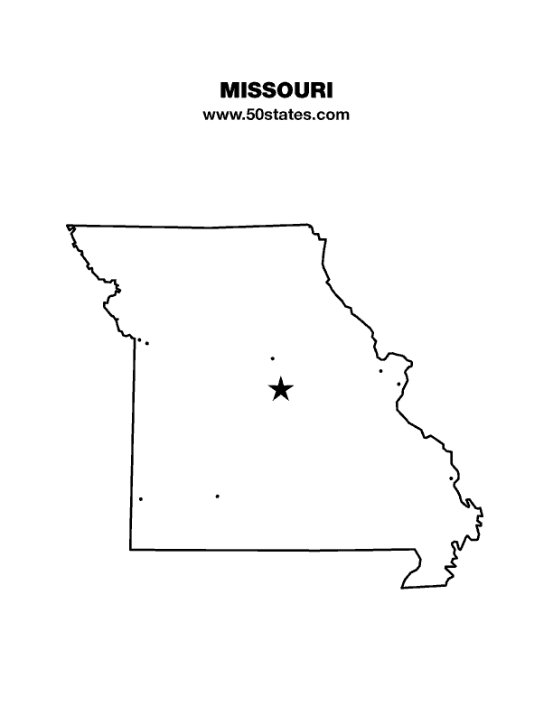
The Blind Missourian
September 2021

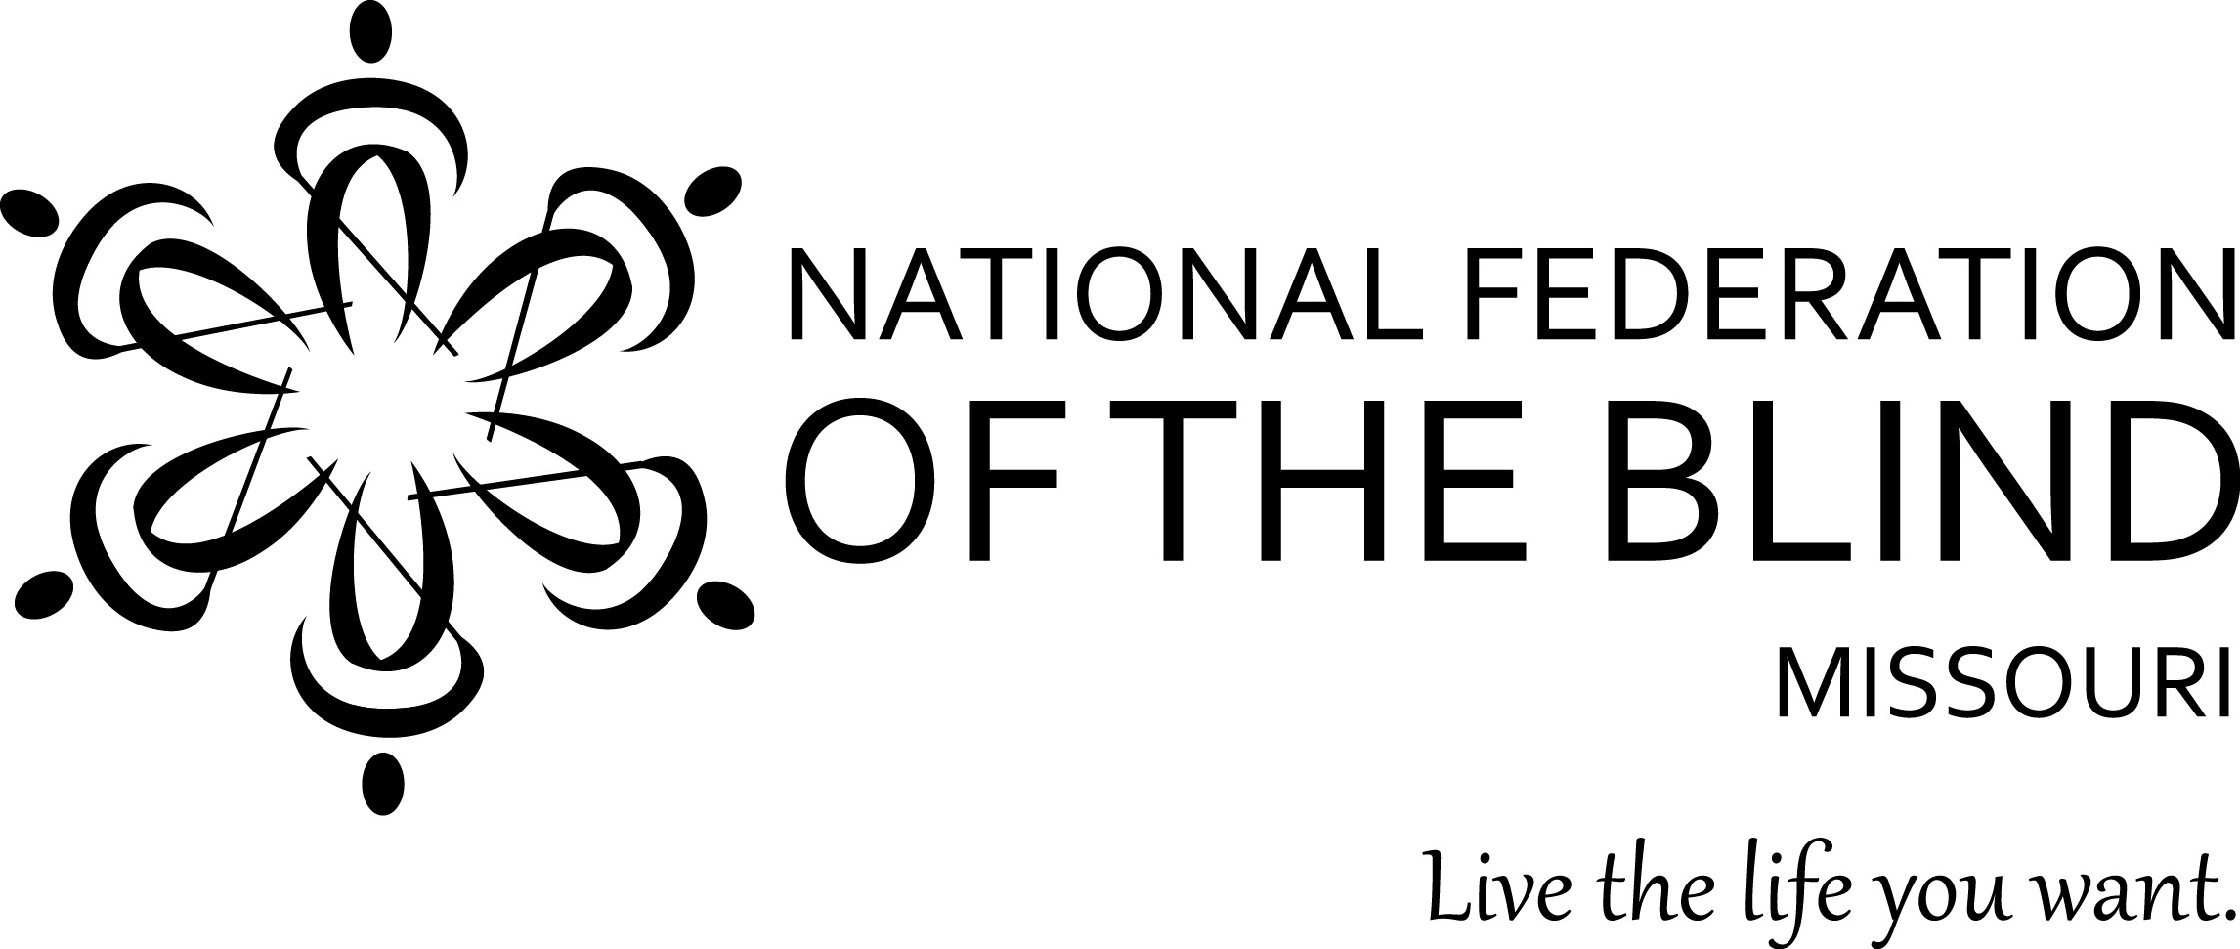

Table of Contents

Connecting the Dots: Chapter, State, and National
by Gary Wunder 1

Youth Programs by Jenny Carmack 5

What is on Your Plate? by Carol Coulter 7

We Have Lift-Off by Eugene Coulter 8

Learning More from Our Past by Eugene Coulter 9

Condolences 11

One Minute Message 11

NFB Pledge 11

Connecting the Dots: Chapter, State, and National
by Gary Wunder

This presentation was given at the leadership seminar held May 22, 2021, using the National Federation of the Blind of Missouri’s Zoom room.

When I came into the National Federation of the Blind in 1972, we had a problem organizationally called localitis. People thought of themselves as being a part of St. Louis, Kansas City, Warrensburg, or Columbia. Yes, they were associated with the state, but it was called just that: the state, and it was certainly a bit remote and different from their chapter. They knew about the offices that the national had in Iowa and California, but they weren’t referred to as our national offices, but instead as them and they, the outsiders whose name we might share but who were definitely not us and we were definitely not them. They gave us some good things in the form of publications and other literature, but those other, higher entities were always on the prowl for money, and we had to watch our funds. We had to be careful not to give them control. I know of times when certain members were so interested in controlling information that they would actually tell the state and national bodies “my members just aren’t ready for you in the Federation, yet.” The words of localitis were “this is ours, not theirs. These are our members, even if organizationally we are associated with the state and the national.”

We’ve moved beyond this today, but perhaps we have done so to an unhealthy extreme. Sometimes we forget that the chapter is the root of our tree, the foundation of our organizational house, and we cannot build on what is not strong. Sometimes we look to our state affiliate and national body to do programs that we should be handling here at home. How should our local police learn about the white cane law? From us locally, I believe. How should voting officials know about our needs and we know about their stance on issues and responsiveness to us? Of course, the answer is through our local chapters.

I would love to tell you that the Columbia chapter is a model for all that a chapter should be, but we haven’t always demonstrated this kind of involvement. Audible signals got installed in Columbia, Missouri, before we were even aware they were going in. Why is that? In part it was because we had already made our stance clear: we didn’t like audible signals. The fact that our policies changed over the years didn’t alter the fact that what people remembered was what we thought in yesteryear, and we did not have close enough relations to update our local officials. We now are responsible for at least one audible traffic signal in Columbia, but we still aren’t on the Columbia Disabilities Commission, and if we really want to know what’s going on locally and influence at, this is where we have to go.

Chapters are the best places to start building membership: they are where we can talk to people directly, visit them in their homes or invite them to ours, go out to dinner with them at a restaurant, and help them easily get to meetings. I know that my coming to the National Federation of the Blind had a lot more to do with developing personal relationships and trying to keep the people I liked so much happy with me than it did with any particular policies or positions the organization might espouse. Later I grew into caring very much about the views of the National Federation of the Blind, but at first, I simply wanted to be looked upon with favor by those who took an interest in me. If they said we’re going to march in the parade, we marched in the parade. If they said they were going to send me a magazine and that I should read it each month and be prepared to talk about it, I watched the mail for the magazine, I read it, and I demonstrated my caring for them by being able to talk about what was there. I didn’t know how much of it was true; some of it actually conflicted with my upbringing and my perception about blindness. Discrimination was a word I associated with minorities, and at that point I did not consider myself a minority. But my friend said I should think about it, and because they were as close as the telephone, a chapter meeting, and some other in- person visits, I took seriously what they said.

Everybody knows that all creativity doesn’t start and stop at the chapter level. In 1966 the first draft of what we now call The Model White Cane Law was drafted by Jacobus tenBroek and published in the California Law Review. The National Federation of the Blind said that it should be passed on a state-by-state level, so Missouri set out to do that. The problem that the law intended to address was so important that it justified a statewide effort and statewide coverage. We had to introduce that bill eight times, but eventually it was passed.

It became apparent that other issues needed more than citywide coverage. We wanted the right to buy life and health insurance, so we went to the state insurance commissioner, made our best case, and got a regulation passed saying that no insurance carrier could discriminate against a blind applicant unless there were statistics to show that that blind applicant posed a more significant risk than others. The insurance companies argued that it just made sense that we were more of a risk than sighted people, but the insurance commissioner said that so-called common sense perceptions would not substitute for actuarial data, and now we have that coverage.

When we realized that a number of us had teenage children who needed to learn to drive, and the laws of the state said that the instruction had to be provided by a parent or guardian, we went to work and got that law changed. I can’t give you the specific citation for it, but it is enough that we call it Larry’s law because it was passed in large part so that Larry Coulter could learn to drive. He now works at NASA, and we have some small part in that success.

When it comes to Braille, we work at the local level, but we know that many of these programs that are implemented will require both local and statewide reform. So again, we look to the affiliate for assistance, get bills introduced, and testify on their behalf. We have traveled a long road to help get literacy for blind people, and I don’t believe that we are nearing the end of it, but we know about a blind driver challenge, and we will drive until Braille is really the default for blind people in the state.

So how do we decide whether something is a local, state, or national issue? It isn’t just the scope of what we want that makes the determination. Sometimes it is the expertise and even the funding that makes the difference. Sometimes a chapter can’t find a lawyer with the expertise that it needs, but the affiliate can. Sometimes the affiliate can’t find the expertise it needs in accounting, but the national body can.

Quite often we find that things we want don’t make any sense to seek at a state level. Microsoft sells programs in every state, and it is not likely to modify what it offers for only one of them. The same is true for car manufacturers. We want cars that make enough sound for us to travel safely, and the car manufacturers don’t want fifty-two different state regulations. So we and they work on legislation leading to regulations, and they cover the entirety of our nation. Those regulations have recently gone into effect, and all new hybrid vehicles are to make enough usable sound that one can be aware of their presence through the sense of hearing. Sometimes the things we work on enhance lives; sometimes what we do saves them. I think this falls into that category.

We often talk about the power of a donated dollar and what it can do on behalf of blind people. We know that in general we get more from dollars spent at the affiliate level than we do at the chapter level, and this is multiplied significantly when we spend dollars at the national level. What is true for money is also true for people and resources. When I wanted to become a computer programmer, I couldn’t find anyone in Warrensburg, Missouri, to help me, but there was a fellow in Kansas City who worked at the United States Department of Agriculture, and he had lots of help to offer. Then there was this group of computer scientists at the national level, and they had hundreds of people working in the field.

We need the National Federation of the Blind at all levels—all levels—and we dare not overlook any of them. Neither should we take them for granted.

If we aren’t moving forward, we are moving backward. Standing still is not an option. If we stand still, the people who are members will become bored, and they will vote with their feet and quit. Some who won’t quit will die. We must recruit people and see that the Federation meets not the needs of yesterday but the needs of today and tomorrow. But whether we move forward and backward isn’t limited just to membership; it also extends to money. If we fail to spend our money, it is likely that we will lose out to inflation. If we hoard what we have, we will forget how to fund raise. If we spend our money on programs that people consider irrelevant, we have wasted it and the potential that it might’ve done had we been wiser in our handling of the purse strings.

We must adapt and advance or consign ourselves to what once was, to the pages of history. I am not ready to passively stand by and watch as that happens. I think that the problems we face today are just as significant as those that people faced when I first joined. They are different problems: problems that are more subtle, problems that are more technical, problems that are more difficult to explain both to sighted people and blind people. One of our problems is that we have climbed just high enough to be comfortable; it is one thing to be supported by the safety net but quite another to be so entangled in it that it stifles our progress. When one is hungry, it is easy to decide to hunt, but when one is full, it is harder to remember that we need to work with the thought of winter in mind.

I want our Federation to continue, not because of its history but because of its potential to do for blind people of today and tomorrow what it has done for me. This means strength at all levels, programs at all levels, loving at all levels, and putting energy to make that love real. Almost every good speech I’ve ever heard concludes by saying that we will certainly make the grade, but I want to leave you with just a little discomfort: you and I will decide whether we make the grade, and as I age, that burden shifts more from me to you. I hope that we do a good enough job of selling our Federation to this and future generations that what we have will not disintegrate and leave them faced with the challenge of building something completely new and different. However it works out, I hope that blind people of today and tomorrow are able to look back on their life and say that it has been made better by their working together for a common cause, believing in one another, and daring to test their dreams against the constraints of reality and learning that the real world indeed has a place for them.

Youth Programs
By Jenny Carmack

The youth in Missouri have been very busy this summer. The prediction is, that as we head into fall more of the same will be happening. There is something for students of all ages to do. Take a look at what has been going on over the summer.

The BELL (Braille Enrichment for Literacy and Learning) Academy was offered virtually for students ages 4-12 this summer. There were three sessions offered (one in June, July, and August). Within each session, students were divided up into groups based on their level of Braille skills; this made it easier for teachers to offer activities to keep bell ringers engaged and progressing. There were eight bell ringers from Missouri, four of whom are new to the BELL Academy. Each bell ringer received a box of materials to use during their daily lessons and to keep for further use. One of our younger bell ringers said that she enjoyed using the foam shapes to make other shapes and pictures of things. For young children, the manipulation of the foam shapes helps them to build tactile skills necessary for reading Braille and deciphering tactile graphics. One of the older bell ringers said that she liked the lessons, but she really loved the social hour and being able to talk to students from other states. As we work to build Braille and other skills, we need to remember the importance of helping bell ringers to also build social skills and develop relationships with peers. All of the bell ringers were glad to have the opportunity to participate in the BELL Academy, but they also are excited to get together in person. Stay tuned for upcoming BELL Academy events.

In November of 2019 a group for teens began, called The Cane Drivers. This group of students ages 13-19 has been actively working to grow and make connections despite the struggles created by the pandemic. The Cane Drivers is a teen-lead group that works on skills such as leadership, team building, independence, and socializing. This group has done a variety of activities such as: played Cooking Jeopardy, prepared homemade pizza for lunch, played name that tune, role playing to problem solve different social situations, participated in a book club, and more. Currently the group is working to create an events calendar of virtual and in person activities. This group meets virtually the second Saturday of each month at 7 PM. All teens are welcome and encouraged to come and check it out.

The Missouri Association of Blind Students (MOABS) has been growing and holding some very informational panel discussions over the summer on topics such as “participating in sports, competitively or leisurely” and ”going back to school in style.” MOABS welcomes students high school age through college level. For students, MOABS is a great resource for topics related to education, accessible technology, applying to colleges, searching for scholarships, extra-curricular activities, and connecting with other students. MOABS meets the first Thursday of each month over Zoom. If you are a high school or college student of any age, join in and see what it is all about.

The newest youth program in Missouri is for students ages 14-21, who are preparing for their future endeavors after graduating high school. This program is called, Mission BEAM (Blindness Empowerment, Advocacy, & Mentoring). A committee of 6 people have been working diligently to develop and prepare to launch the program. The program is designed to be a mentorship-based program in which mentors will work with mentees (students) to enhance their skills in self advocacy, independent living, career exploration, vocational exploration, resume writing, independent travel, and more. Although Mission BEAM has not yet deployed the full year-round program, there was a workshop for students held on August 7th. The workshop was on “Self-Advocacy” and “IEPs and Student Participation”. During this workshop students had the opportunity to share their own experiences related to the topics, participate in role playing to work on advocating in a variety of situations, partake in a game to help them learn about parts of the IEP and effectively write an IEP goal. According to survey results, students gained some new knowledge from their participation in the workshop and would like to participate in another Mission BEAM activity. The committee continues to work toward rolling out the full program; be on the lookout for more information on the Mission BEAM program.

As you can see, there is something in Missouri for students of all ages. If you are a student, we invite you to come and see what we are all about, and if you know a student, encourage them to get involved. Students across Missouri are learning a lot and having fun!!! For more information on any of the programs in this article or other youth related topics, please reach out to us by emailing, youth-programs@nfbmo.org

What is on Your Plate?
By Carol Coulter

The Sports and Recreation Committee has been struggling with what to do during this pandemic. The inability to gather to do any sporting event has been a struggle. The committee would not be stopped and came up with the idea of offering a virtual nutrition class; after all, exercise is not the only aspect of a healthy body. Now the search was on to find a person qualified to teach the class. We were very fortunate to have found just the right person. Not only was she a member of the National Federation of the Blind in Baltimore, Maryland, she also offered to do the classes for free.

Lynn Baillif has a master’s degree in nutrition and is a Registered Dietitian with twenty-five years of experience, and she did a fantastic job running the seminar. Mrs. Baillif also offered some free individual nutritional coach trainings to those who participated in the seminar. The Health and Wellness; Living the Life You Want Seminar sponsored by the National Federation of the Blind of Missouri and the Sports and Recreation Committee of the National Federation of the Blind of Missouri was free and was held every Monday evening at 7 pm, from November 16, 2020 through August 9, 2021.
The seminar covered a wide range of topics. We discussed the expected topics such as: vitamins, minerals, fats, proteins and carbohydrates, etc. Lynn explained what could happen when you are deficient in these nutrients as well as the toxicity levels and what side effects that can have on your body. She told us about the “healthy plate”, so you could ensure you were getting the right amount of everything.

Several other topics included: Label reading, fad diets, shopping tips, healthy cooking techniques, exercise, goal setting, and how to stay motivated. We also talked about diabetes and how to help manage it with your diet. Another very interesting topic was how various foods could help in the prevention of different types of cancers, because of the nutrients they contained.

One thing I found interesting was that our cholesterol levels in our bodies are not affected by the cholesterol in our food, but by the types of fat we eat. So, some fats are bad and some are good. Unfortunately, bacon is on the wrong side of the fence.
We can’t thank Lynn Baillif enough for all her time and the amount of work she put into this seminar. I have over a hundred pages of handouts she prepared and shared with us. This information is on my computer, but I am working on putting it in a binder so I have another way of quickly referring back to the information. The seminar was recorded, so if you would like to listen to it contact President Shelia Wright at Sbwright95@gmail.com or Randy Carmack, webmaster at website@nfbmo.org. You will not be able to get the coaching, but you will get all this information and more, including recipes and how to make smart choices when eating out. Thank you again Lynn and we hope to see you in person at our next state convention.

We Have Lift-Off
By Eugene Coulter

Have you ever wondered when something happened or if someone received a particular award? Now over 1,500 files are easily accessible at your fingertips. The Data Retention Committee has compiled every piece of information we could find for all sixty years of the affiliate in one handy place. Anyone can access the public files by going to www.NFBMO.org and clicking on the archive link; there, you will find our files divided into ten areas of interest. There is a search function, so you can find items easily. For example, I put in Jernigan and forty results popped up.

There are not only documents, but also audio and video files. For example, you can hear President Wright’s reaction to being elected at the 2017 convention. There is also a restricted section of files that include minutes and treasurer’s reports. Members can request any of these files by sending an email to Archives@NFBMo.Org, and a committee member will send you the requested information. Also, and this is important, chapters and divisions who are interested in preserving their history are urged to send their files to the same email address, and the files will be uploaded to your very own section of the archives.

Thanks to present and past members of the Data Retention Committee including: Erin Magoon, Randy Carmack, Gary Wunder, Becky Boyer, Dacia Cole, and anyone I forgot. Special thanks to Elisabeth and Carol Coulter, Shelia Wright and Julie McGinnity for help in securing many files. My very conservative guess is that altogether well over 500 hours went into this project. Please check it out, and give us your feedback.

Learning More from Our Past
By Eugene Coulter

In the last issue I provided some random memories of past events, but as this November marks the 60th birthday of the Missouri Affiliate, I thought I would look back on what happened at the beginning of each decade. At the end of this article are the answers to the trivia quiz from the last issue. Let me know if you would like more trivia quiz.

1961: George Rittgers convened the organizing meeting in Kansas City with twelve folks present called the Federated Blind. Prior to our first convention which was held in Jefferson City in 1962, our name was changed to the Progressive Blind. There were twenty members present at that convention.

1971: The Model White Cane Law was first introduced in the state legislature to guarantee blind persons equal treatment; it was finally passed in 1977. The Progressive Blind began expanding outside of Kansas City establishing the Saint Louis Chapter. The position of Second Vice President was created, and Gerald Salter was elected to fill the new position.

1981: Our Jefferson City Chapter was founded on May 27 of this year. We were also working for elimination of the sub-minimum wage in workshops. According to this publication at the national convention in Baltimore four scholarships would be awarded.

1991: President Gary Wunder at our convention in Kansas City celebrated the passage of the state’s Children at Risk bill which included our Braille Bill providing for our blind children to be taught Braille in school. At the same convention, James Moynihan received the Kenneth Jernigan Award
.
2001: We passed thirteen resolutions at our convention in Columbia dealing with expanding Newsline for the Blind, the need to hire more Blindness Skills Specialists, and funding for Rehabilitation Services for the Blind. Our awards were presented to Martha Young (Jernigan), Cora Underwood (tenBroek), and John and Sandy Halverson (Affiliate). The Halverson’s were presented their award in January as they were leaving our state.

2011: We successfully passed a bill protecting the parental rights of blind and disabled parents in the aftermath of the Baby Makayla Case. We also passed seven resolutions including one demanding accessible voting machines in state and local elections. Martha Kelly was presented the Affiliate Award.

2021: We held our second, and hopefully last, virtual convention passing only one resolution proclaiming that we will take all required action to assure our voting rights in all elections. We, along with other organizations, were successful in getting a law passed to guarantee parents the right to record IEP meetings.

Here are the answers to the Trivia Quiz from last issue:

1. According to this publication when did NFB Newsline Start in Missouri? March 15, 2002.

2. Since 1971 how many editors has this publication had? Eleven: Patricia Morrow was editor for twenty years and Carol Coulter twelve years and counting. (Twelve is an acceptable answer as Tom Steven had two stints).

4. In what cities have we had state convention (Suburbs of Kansas City and Saint Louis are considered as being part of those cities)? Columbia, Hannibal, Jefferson City, Kansas City, Kirksville, Saint Joseph, Saint Louis, Springfield.

5. Who served the longest as a chairman of any state committee having served for twenty-three years? Name the person and the important committee they chaired. Bill Neal on Ways and Means Committee

6. How many years did Shelia Wright spend as First Vice President? Fourteen

7. In What year did the Model White Cane Law pass in Missouri? 1977, SB 12.

8. Who was Gary Wunder’s first Guide Dog? Eli

9. Name four chapters that served the Saint Louis area. Lewis and Clark, St. Louis, Mississippi Triangle, and Gateway City.

9. Which of these have been state affiliate fundraisers? Wooden toys, stuffed animals, t shirts, candy, carved elephants, raffles. All of them.

10. In what year did the student division host the state convention and in what city? 1979 in Columbia

Condolences
Please keep Sue Tussey in your thoughts and prayers. On July 14, 2021 she said goodbye to her beautiful guide dog Sahara. Sahara was almost fourteen years old and had given a full life of service and companionship to Sue. While this period of grief is difficult, Sue is looking to the future with the hope of welcoming a new guide dog into her life by the end of the year.

One Minute Message

The National Federation of the Blind knows that blindness is not the characteristic that defines you or your future. Every day we raise the expectations of blind people, because low expectations create obstacles between blind people and our dreams. You can live the life you want; blindness is not what holds you back.

Pledge of the
National Federation of the Blind

I pledge to participate actively in the efforts of the National Federation of the Blind to achieve equality, opportunity, and security for the blind; to support the policies and programs of the Federation; and to abide by its Constitution.

Board of Directors
National Federation of the Blind of Missouri

Officers:
Shelia Wright, President Melissa Kane, First Vice President
Jenny Carmack, Second Vice President Becky Boyer, Recording Secretary
Daniel Garcia, Corresponding Secretary Carol Coulter, Treasurer

Board Members:
Eugene Coulter Dennis Miller Robin House
Amy Wilson Chris Tisdal Randy Carmack
Jeff Giffen President Emeritus, Gary Wunder

Chapter Presidents
Columbia Chapter, Gary Wunder, 573-874-1774
Old Drum Chapter, Warrensburg, Amy Wilson, 660-441-1907
Jefferson City Chapter, Rita Lynch, 573-634-3865
Springfield Chapter, Carolyn McGhee, 573-673-7904
Kansas City Chapter, Daniel Garcia, 816-505-5520
Lewis and Clark Chapter, St. Louis, Chris Tisdal, 314-440-1684
Mineral Area Chapter, Farmington, Roger Crome, 573-701-8409
Show Me State Chapter, meets via conference call, Dennis Miller, 660-234-5351
Ivanhoe Chapter, Kansas City, James White 816-923-7074

Blind Missourian Editor Carol Coulter
Proof Readers: Shelia Wright, Daniel Garcia and Grace Warn
Read by Elisabeth Coulter

FREE MATTER FOR THE

BLIND AND PHYSICALLY

HANDICAPPED

NFB of Missouri
1504 Furlong Dr.
Columbia, MO 65202

