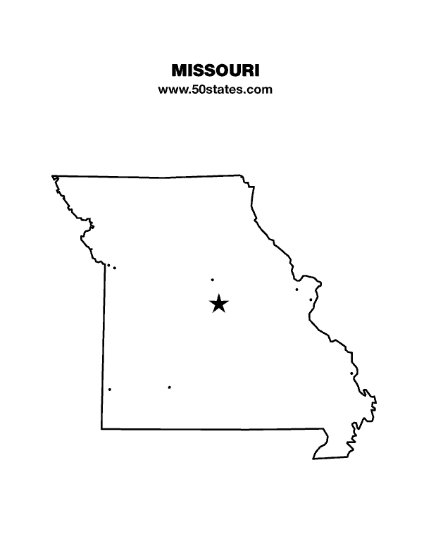
The Blind Missourian
March 2021

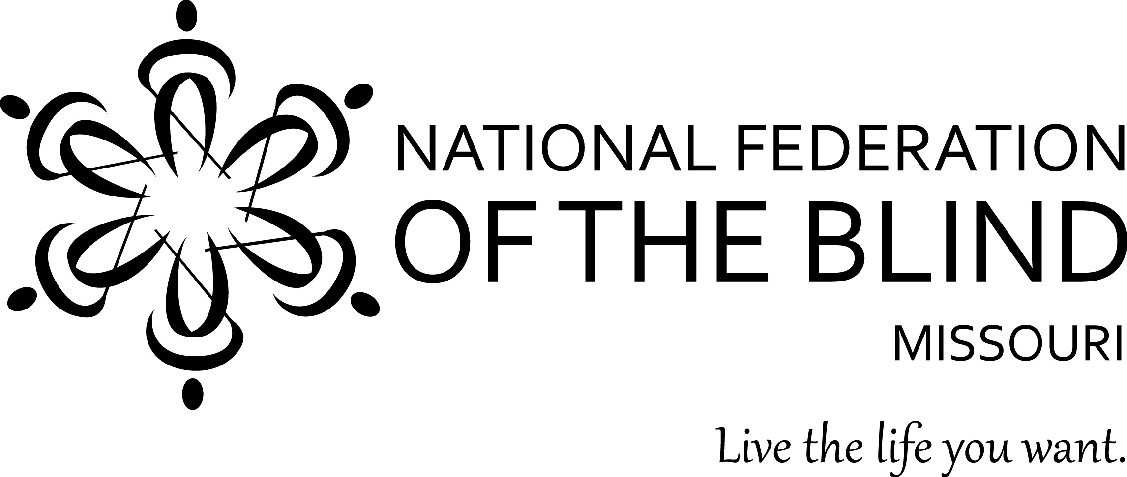

Table of Contents

2021 Legislative Fact Sheet 1

Additional Information to Keep in Mind by Roger Crome 6

Nothing Stops Us- The Jefferson City Seminar
by Gene Coulter 8

Attending the First Ever Virtual Washington
Seminar by Dennis Miller 9

Letters of Gratitude for the NFB by Carol Coulter 11

Rada cutlery fundraiser by Carol Morgan 11

Smile for The NFB of Missouri by Dennis Miller 12

One Minute Message

The National Federation of the Blind knows that blindness is not the characteristic that defines you or your future. Every day we raise the expectations of blind people, because low expectations create obstacles between blind people and our dreams. You can live the life you want; blindness is not what holds you back.

Pledge of the
National Federation of the Blind

I pledge to participate actively in the efforts of the National Federation of the Blind to achieve equality, opportunity, and security for the blind; to support the policies and programs of the Federation; and to abide by its Constitution.

Shelia Wright, President
7928 NW Milrey Drive
Kansas City, MO 64152
Phone (816) 741-6402
www.nfbmo.org
LEGISLATIVE AGENDA OF BLIND MISSOURIANS

PRESENTED TO
THE first SESSION of the ONE HUNDRETH and First GENERAL ASSEMBLY

From: The National Federation of the Blind of Missouri

Date: February 15 through 19, 2021

The National Federation of the Blind knows that blindness is not the characteristic that defines us or our future. Every day we raise the expectations of blind people, because low expectations create obstacles between blind people and our dreams. Blindness is not what holds us back.

This is the message we bring to blind Missourians and the communities we live in. We pledge to be a resource to you and your constituents when they turn to you for help.

The National Federation of the Blind is a membership organization of and for the blind. As a volunteer, grassroots organization, we are blind people working on behalf of blind people. We come together on the local, state, and national level to address issues of importance to our fellow blind citizens. We promote programs that encourage self-determination, independence, and equality of opportunity.

Why Braille Is A Necessary Part of The Independence and Success of the Blind

It is said that learning to read is one of the greatest accomplishments of man, and if blind people are to succeed, literacy must be a part of our skill set. This is why we have Braille, the finger equivalent of what most see with their eyes. Only when literate are we able to meet the challenge of expanding our knowledge on a wide variety of subjects and gain an understanding of our world. By using Braille, we are able to read things for ourselves. While audio and electronic means of access are essential to living in our society in the age of advanced technology, there is no substitute for reading something yourself. The importance of having the ability to communicate in writing and knowing where to use punctuation and understanding how to spell is a fundamental skill. Especially is this so if you plan to do a white-collar job.

In our schools, less than 10% of blind children are getting the benefit of learning Braille. At least part of the problem is determining early on who will be most efficient reading Braille, who will be so using print, and which children can benefit significantly from learning both. Print is too often decided upon because it is considered normal, but children who are functionally blind but have some sight pay the cost in eye strain, headaches, and the inability to read rapidly or for long periods. Our blind children soon associate reading with discomfort and real pain.

Studies clearly show that most blind people who are employed know and use Braille. This should speak volumes to the need for it, but while sighted students are learning to read, blind students are being evaluated using a number of inadequate tools. By the time students are expected to read in order to learn, our schools are just deciding to teach our blind children to read Braille. The forecast is gloomy; they are behind, and unless they and their teachers and outside tutors make a herculean effort, this is where they will stay—behind.

Getting and keeping a job relies on skills. Fundamental among these are reading and writing. Audio and video enhance the lives of our citizens, but they do not replace reading and writing, especially for blind folks. As the governor makes one of his priorities employment first, we have the responsibility to do what will make blind people employable and provide for them and the rest of our society the fruits that productivity brings to us all. To this end, we believe that a comprehensive approach to enhancing the educational experience for all students with blindness or low vision is not only the right thing to do but is absolutely necessary if the blind youth of today are to compete with their peers in the future global market.

Blind Students Rights to Independence Training and Education Act (Henceforth referred to as the BRITE Act)

In the spirit of addressing the building of literacy and capacity for success, we would like to offer proposed language for a piece of legislation that will enhance the education of blind children through a comprehensive approach. This Act would require an increase in the availability and utilization of Braille instruction for all children that would benefit from the learning of this skillset. The Act outlines an approach of addressing Braille instruction and combining this with a range of Assistive Technology that would be available to the student in the classroom and at home. Another important aspect to independence and success in competitive employment is the access to Orientation and Mobility which is necessary for the blind to learn to navigate independently using the available tools and learning to increase recognition of tactile and audible clues to assist in safe, independent navigation. Additionally, the BRITE Act encourages proactivity of those involved in the instruction of blind students through continuous education and self- improvement for these professionals. The NFB is asking for your help to create an equal and fruitful learning environment for all children. You can make a difference by sponsoring the proposed legislation as described in the attached BRITE Act proposed language.

Blind Pension Legislation

HB 117, sponsored by Representative Walsh-Moore, has one simple but essential function, to remove the word certified from the law regarding correspondence with blind pension recipients. The well-intentioned insertion of the word certified has caused significant expense to the state as well as to blind recipients who are often forced to go to the post office to pick up mail that would otherwise be found in their box. Not only is this an unnecessary expense; it reduces the time blind pension recipients have to fill out the yearly recertification required and has caused a number of blind people to be terminated and subsequently reinstated, again at significant cost to the state of Missouri and its blind residents who receive the pension. Therefore, HB 117 seeks to remove the word certified from the laws governing Blind Pension. Many blind Missourians have experienced significant issues due to the certified mail requirement, and that is why the National Federation of the Blind of Missouri strongly supports this legislation as presented.

The Recording of IEP and 504 Meetings

HB 228 (Representative Basye) and SB 134 (Senator O’laughlin) seeks to allow parents and legal guardians to record IEP and 504 meetings. Often meetings are long, and having good notes is crucial. The IEP team consists of the parents and half a dozen or more school personnel. A lot of information is exchanged, and some of it is highly technical and difficult for parents to initially understand. If one is blind and the information is presented in a form he or she cannot read, the problem becomes even more difficult and added emphasis falls to understanding exactly what is said. even if the parents are able to follow along well enough to fully participate in the decision making, recalling the necessity and reasoning for certain decisions is difficult at best. For many people who are blind, an effective method for taking notes is to record the meeting. Unfortunately, many school districts have put policies into place to limit the access to this method for parents and guardians. This leads to misunderstanding and frustration for both parents and school personnel. Therefore, the National Federation of the Blind of Missouri supports this legislation, and on behalf of blind parents in Missouri, we ask you to support the passage of HB228 and SB 134.

Accessible Voting in All Elections

There are multiple bills that have been introduced in the House that address voting from a variety of points of view. The National Federation of the Blind believes that the ability to securely and independently cast a private ballot is a sacred promise allowed to every American through our constitution. We understand that discussions must be had related to voting. It is in the spirit of this understanding that we are not promoting or opposing any particular piece of legislation. We are, however, re-stating our position on the imperativeness of accessible voting for all of us. Below, we discuss the reasons behind our assertions and ask that, as you debate voting legislation throughout the session, you keep in mind how sacred your vote counting is to you. With this in mind, you will better empathize with our positions and the value we place on casting a ballot independently and privately.
The Help America Vote Act (HAVA) recognizes the right of the blind to vote privately and independently by requiring nonvisual access for the blind through the use of accessible voting systems in all federal elections. Electronic voting technologies, designed and properly configured with nonvisual access, provide blind voters with the ability to cast their votes privately and independently and to verify, without sighted assistance, that their ballots accurately reflect their voting choices. Electronic voting systems were certified and purchased, and Missouri received federal funds for each polling place to provide at least one accessible voting machine. All certified machines in Missouri provide a paper trail.

The Missouri Secretary of State’s Office is evaluating newer machines that mark directly onto the paper ballot. The options are there if legislation to make the paper ballot the official ballot of Missouri is passed. The work of the Secretary of State will also be invaluable when the existing machines need to be replaced.

Accessible machines are already required for the state to comply with HAVA. Some election boards may set these machines up more frequently than others. We ask that they be used consistently in all elections. The cost of setting them up should be minimal since “text to speech” options are available. Concerted efforts are made to get voters to the polls; Missouri should assure that when they arrive, they have the means to cast their ballots privately and independently.

Beyond the example and financial assistance HAVA has provided to emphasize accessible voting, there are two federal laws that require all elections to be accessible to bring Missouri into compliance. Voters with disabilities have the same right to vote privately and independently as do voters without disabilities. When accessible voting machines are not present in state, county, and municipal elections, blind, visually impaired, and other print disabled voters are denied an equal opportunity to cast their ballot privately and independently. This is a violation of Title II of the Americans with Disabilities Act and Section 504 of the Rehabilitation Act of 1973. As a recipient of federal funds, Missouri and our Election Boards are required to comply with Section 504 of the Rehabilitation Act.

Additionally, the Americans with Disabilities Act guarantees equal access for individuals with disabilities to the benefits of the services, programs, or activities of a public entity. Public entities must provide individuals with disabilities an aid, benefit, or service that is as effective in affording equal opportunity to gain the same result or benefit as provided to others. Public entities shall furnish appropriate auxiliary aids and services where necessary to afford individuals with disabilities an equal opportunity to participate in and enjoy the benefits of a service, program, or activity of a public entity. To be effective, the auxiliary aids and services must be provided in such a way as to protect the privacy and independence of the individual with a disability.

Whether the financial responsibility falls on the State of Missouri or the County Election Boards is a technicality that must not continue to preclude the full participation of blind, visually impaired, or other Missourians with disabilities who could benefit from the use of accessible voting equipment. Please assert due diligence in regard to bridging the gap that has prevented this legislation from passing in the past, and grant people with disabilities the opportunity and the right afforded us to have the same privilege in every election that you value and take for granted as your right as a citizen of Missouri and of the United States of America.

Additional Information to Keep in Mind
By Roger Crome Governmental Affairs Committee Chair

The following information is provided to offer a window into the things we find important. No specific legislation is connected to these pieces of information, but we would ask that you keep these priorities in mind as the legislative session progress

Accessible Medication Labeling

Taking medication as prescribed is an essential aspect of remaining healthy. This chore is one that can become extremely challenging at best and can result in medication errors that result in critical illness and even death if the wrong medication is taken. Many people that are blind rely on the shape and size of medication bottles, the type of lid on the bottle, the size and shape of the medication itself and the feeling of the inscription or split lines on the medication. The problem with this method is that bottles can remain the same size with similar lids for months or years, and suddenly, either the manufacturer or the pharmacy changes it up for whatever reason. A pill that is small and squared may have a brand that is more economical for the pharmacy that produces this pill in a larger oblong format. Some brands of medications are solid caplets while others are capsules. With all of this in mind, it is not a far stretch to see how this could become problematic if you could not read the label. There is technology available to create labels that provide an audible output as well as braille and large print. This technology requires pharmacy staff to run the medication bottles through a label maker based on the end user’s mode of accessibility. Many pharmacies use this labeling, but unfortunately, some chain pharmacies may not want to offer the accessibility if there is another pharmacy within 25 miles. This becomes problematic for those without access to transportation that will take the person to the pharmacy that offers this level of accessibility. Other states have legislatively addressed this issue based on the desire for businesses within their state to become compliant with the ADA and Section 504 of the Rehabilitation Act of 1973. We believe this issue is of great importance and would welcome the opportunity to work with you on the development of legislation that resolves this situation.

Salary Range for Rehabilitation Services for the Blind Counselors

The National Federation of the Blind is a strong proponent of education and training as the doorway to fulfilling the dream of living the lives we want. The Vocational Rehabilitation counselors working for Rehabilitation Services for the Blind are a valuable asset contributing to the success of blind Missourians. Unfortunately, the salary paid these valuable men and women is markedly less than the Vocational Rehabilitation counselors for those with other disabilities who work for the Division of Vocational Rehabilitation.
For years, Rehabilitation Services for the Blind has had a problem attracting and keeping highly qualified counselors with a Master’s Degree and a level of experience that translates into quality, competent, dedicated, and effective counselors. The National Federation of the Blind of Missouri has encouraged raising the pay of RSB counselors to the same salary range as their VR counterparts. This will result in the recruitment and retention of highly motivated and empathetic professionals. Regrettably our suggestions have gone unheeded, and as a result, the recruitment and retention of qualified rehabilitation professionals continues to be a problem.
Missouri already has a template of salary ranges for equivalent positions as identified through the Department of Elementary and Secondary Education’s Division of Vocational Rehabilitation. It is just common sense that those doing the same kind of job should reap the same reward. We urge you to explore this issue and collaborate with your colleagues to find an equitable solution to this injustice that results in the lack of acquisition and retention of individuals who will help blind Missourians to navigate from their dreams to living the life we want. It is important to note that Missouri’s Vocational Rehabilitation counselors through Rehabilitation Services for the Blind are performing at a quantitively successful level. The employment retention rate of Missouri clients of Rehabilitation Services for the Blind is higher than anywhere else in the country. If we want to continue this success and demonstrate appreciation for the dedication and hard work that these counselors competently demonstrate, we must consider the value of paying these individuals a rate equivalent to their counterparts in Vocational Rehabilitation.

Safe Travel

Missouri has recognized October 15th as White Cane Awareness Day. The resolutions attached to this day acknowledge the importance of the blind to use a white cane or guide dog as necessary tools to safe and competent navigation. The National Federation of the Blind of Missouri has been increasingly receiving reports of issues related to distracted drivers who are not yielding for pedestrians using white canes or guide dogs. Something needs to be done to consistently reinforce the laws that are already in place to protect the health and wellbeing of blind pedestrians. Between the lack of consistent enforcement and the inadequate severity of punishment, many drivers are ignoring what should be common sense, and too many blind people are experiencing near misses or being struck by cars. We believe that the legislature has the responsibility and the ability to implement changes to address the increasing issues faced due to distracted drivers and the failure of drivers to learn the necessity of yielding to those using a white cane or guide dog.

Nothing stops us – The Jefferson City Seminar
By Eugene Coulter

The 2021 Jefferson City Seminar will forever show how dedicated members of the National Federation of the Blind of Missouri are to making life better for blind persons in our state. We knew several months ago that the event would have to be virtual, so the Governmental Affairs Committee along with members from throughout the state began planning for Zoom meetings. The one thing we did not count on was the weather; with ice, snow, record low temperatures, and wind chill readings of 25 degrees below zero, our already planned Zoom calls kept us from canceling due to the inclement weather.
It was in some ways a blessing that because of the Corona Virus we held the seminar virtually and because of the weather the General Assembly was not in session that week. If we had managed to make it to the capitol, we would have battled the cold only to find mostly empty offices. As it was, making appointments became a challenge but through our perseverance dozens of appointments were held over the next several days.
The reaction of members to our priorities was overall very positive. We were assured that the bill regarding the recording of Individual Education Plan meetings was well on its way to being passed as it is almost through the House. There was interest in our proposal to make prescription drugs accessible. While I believe most legislators agreed with the principal that we should be able to vote without sighted assistance, it did not seem that it is a priority for them.
The bill to eliminate the certified mail requirement for Blind Pension appears to have little opposition but as of this writing has not had a hearing. It will hopefully make it to the consent calendar and be passed as it was well on its way last year before the Corona Virus shut things down. Another hope is to have the certified mail bill amended into a similar bill doing away with most certified mail for the Department of Revenue.
One of the highlights of our efforts was the progress made on the BRITE Act, see the factsheets in this issue. Members of the Columbia Chapter spoke with Representative Chuck Basye who is chairman of the House Education Committee, and he pledged to do his best to have the bill introduced this session. We also had very positive feedback from other members who also made similar pledges to introduce the bill. While it might be too late to actually get the bill passed this year, we will be setup very well for the 2022 session.
Most of the legislators we spoke with listened attentively and gave us enough time to cover the issues in enough detail that they understood why the issues are important to us. Overall, the Jefferson City Seminar appears to have been a great success again this year. Now it is time for every member to follow-up with their representatives and senators on our issues. Long notes are not required or necessarily desirable. For example, if you want to write a note about HB 117 the Blind Pension certified mail bill, a one or two sentence note would be enough. The first sentence stating that you support the bill and the second sentence stating why. a similar method could be used on other bills.

Attending the First Ever Virtual Washington Seminar
By Dennis Miller

I have been a member of the National Federation of the Blind for several years now, but job commitments and other things had kept me from being able to participate in the Washington Seminar. Because of my background in advocacy and my interest in politics, attending the Washington Seminar was something I had always wanted to do but had never been able to do until this year
The current pandemic has changed a lot in this world we live in, and most of the changes have not been for the better. However, one thing that has changed is that organizations have had to become creative about the way they hold their events, and the NFB has been at the forefront of that. When the national board made the difficult decision to hold the Washington Seminar virtually, I jumped at the opportunity to be involved. I had no idea I would enjoy participating as much as I did.
Late last year President Wright asked me to be a Legislative Director for the state affiliate. Chris Tisdal is the other Legislative Director. My job is to monitor legislation the NFB is supporting or opposing and share that information with the state affiliate via our list serves. As such, I was invited to participate in several pre-seminar trainings the NFB conducted leading up to the seminar. These trainings included extensive review of the four issues the NFB would be bringing before Congress this year, as well as training on how to use the portal the NFB would be utilizing to track our meetings with the various members of Congress and their interest, or in some cases non interest in those issues. It was imperative that we schedule meetings with Missouri’s two senators and eight representatives, and I’m proud to say we did that.
Because of events taking place in Washington DC during the time the Washington Seminar was going on we weren’t always able to meet with the senator or representative themselves, but their legislative assistants were always very knowledgeable and receptive to our issues.
One of the biggest thrills for me was meeting with Representative Vicki Hartzler. President Wright asked me to talk about the Access Technology Affordability Act which is an issue the NFB has been working very hard on for the past couple of years. This was the only issue that actually had been introduced and had a bill number. We were looking for senators and representatives who would co-sponsor this piece of legislation. After asking a couple of very thought-provoking questions, Representative Hartzler indicated she would like to be a co-sponsor for this bill. I was amazed at how easy this whole process was.
Perhaps it was just the virtual environment, or perhaps it was because the four issues we were talking to our congressional representatives about were issues I was passionate about but I found the whole process to be much easier than I expected. Not only that, I really enjoyed doing it.
Another added benefit of attending this year’s virtual seminar was the chance to get to better know some of my fellow affiliate members. You can learn a lot about a person while you are killing time waiting for a particular Congressmen or their assistant to join the Zoom meeting. It reinforced for me something I already knew but love to be reminded of: there are some really cool and knowledgeable people in the National Federation of the Blind of Missouri.

Letters of Gratitude for the NFB
By Carol Coulter

Daniel Garcia, president of our Kansas City Chapter, had seen a request from the editor of The Kansas City Star for readers to submit letters about what they were grateful for, so he decided that he would send a letter expressing his gratitude for the National Federation of the Blind. During their chapter meeting, Daniel asked chapter members to submit their own letters. He reasoned that if several chapter members wrote letters, the chances would be increased that the Star would publish one of the letters. Sure enough, the strategy paid off. The Kansas City Star published a letter from Terra Coccovizzo. Here is Terra’s letter.

This letter originally appeared in The Kansas City Star.

VITAL GUIDANCE
The National Federation of the Blind has made a significant impression on my lifestyle, and I am eternally grateful to the people there for helping me to involve myself and to find friendship and equality.
I have been attending several programs to help me hone my skills as a person and to become another face in the crowd. This assistance has let me live the life I want, which has also helped build my self-esteem to an acceptable level, enough to be able to believe in myself and make the acquaintance of many really good friends.
- Terra Coccovizzo, Kansas City

Rada cutlery fundraiser
Carol Morgan Ways and Means Chair
We are currently joining Rada cutlery for our newest fundraiser. The Rada Cutlery Company is in Iowa. All of their products are made in the USA. Rada cutlery offers knives, kitchen gadgets, and dips, as well as other items. I am sure you will find something to buy.
Our fundraiser has already begun. You can order online or by catalogue. If your customer orders online, the product is shipped to them. The catalogue sales are sent to the seller for them to deliver. Customers ordering from a catalogue make checks to NFB of Missouri, and we send Rada one check. Customers ordering online will receive their orders faster. We have a store link which I will attach. Please share the link with friends and family. If you need a catalogue, let me know. I believe this is a great way for us to earn funds to make possible the worthwhile projects we do. I would like to thank you for participating in this fundraiser. Here is the link: https://radafundraising.com/?rfsn=5295862.06720a

Smile for The NFB of Missouri
By Dennis Miller

Many of us donate to the National Federation of the Blind in a variety of ways. There are all sorts of ways to donate to the national organization but what about the NFB Of Missouri? Did you know there is a quick and easy way to donate to the NFB of Missouri by simply doing something that many of us do on a regular basis without even thinking about it?
Amazon Smile is a program set up by the folks at the Amazon Corporation to give organizations and charities a way to raise money. In fact, they donate 0.5% of every purchase you make to the organization or charity you select. That may not seem like much, but if you are like me you shop at Amazon frequently and over time that 0.5% of each purchase can really add up. With the ongoing pandemic I find myself buying more online than I ever have before, and Amazon Smile allows me to support the NFB of Missouri every time I buy from Amazon.
So, how does the program work? It is actually very easy. Simply go to: http://smile.amazon.com and sign up. The process is very simple. You will be asked to select your charity or organization. Type NFB Kansas City in the search box, then either hit the return key or tab to the search button and press enter. You will be presented with your search results. Select NFB Kansas City and you are signed up. When the NFB of Missouri signed up for the program, Amazon required they provide the address of where the tax-exempt status was maintained, since that address is in Kansas City, Amazon listed us as NFB Kansas City. Rest assured though that all Amazon Smile donations go to the state affiliate and not to an individual chapter. Once you have selected NFB of Kansas City you are ready to start shopping. In the future 0.5% of anything you buy from Amazon will be donated to the NFB of Missouri. Just make sure that whenever you shop at Amazon you do so at the http://smile.amazon.com Web address. Only items bought from that Web address will be credited to the state organization. I would suggest bookmarking this Web site in your Web browser.
An even easier way to do this is to use the Amazon app on your iOS or Android device. Simply go to the app’s settings and activate the Amazon Smile feature and everything you buy using the app will see 0.5% donated to the NFB of Missouri.
Board of Directors
National Federation of the Blind of Missouri

Officers:
Shelia Wright, President Melissa Kane, First Vice President
Jenny Carmack, Second Vice President Becky Boyer, Recording Secretary
Daniel Garcia, Corresponding Secretary Carol Coulter, Treasurer

Board Members:
Eugene Coulter Roger Crome Robin House
Amy Wilson Chris Tisdal Dacia Cole
Jeff Giffen President Emeritus, Gary Wunder

Chapter Presidents
Columbia Chapter, Gary Wunder, 573-874-1774
Old Drum Chapter, Warrensburg, Amy Wilson, 660-441-1907
Jefferson City Chapter, Rita Lynch, 573-634-3865
Springfield Chapter, Carolyn McGhee, 573-673-7904
Kansas City Chapter, Daniel Garcia, 816-505-5520
Lewis and Clark Chapter, St. Louis, Chris Tisdal, 314-440-1684
Mineral Area Chapter, Farmington, Roger Crome, 573-701-8409
Show Me State Chapter, meets via conference call, Dennis Miller, 660-234-5351

Blind Missourian Editor Carol Coulter
Proof Readers Helen Stevens, Shelia Wright, and Daniel Garcia
Read by Elisabeth Coulter

FREE MATTER FOR THE

BLIND AND PHYSICALLY

HANDICAPPED

NFB of Missouri
1504 Furlong Dr.
Columbia, MO 65202

