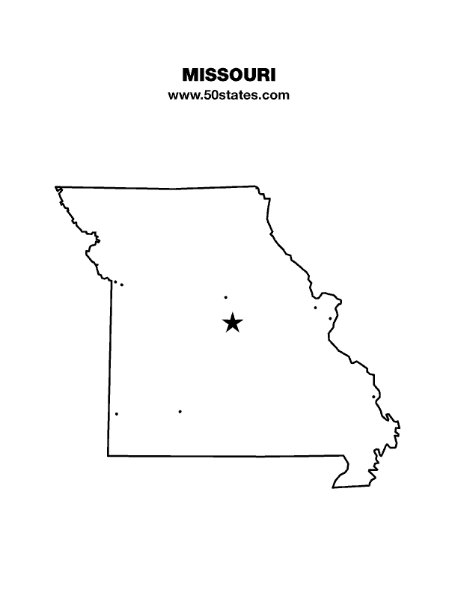
The Blind Missourian
June 2023

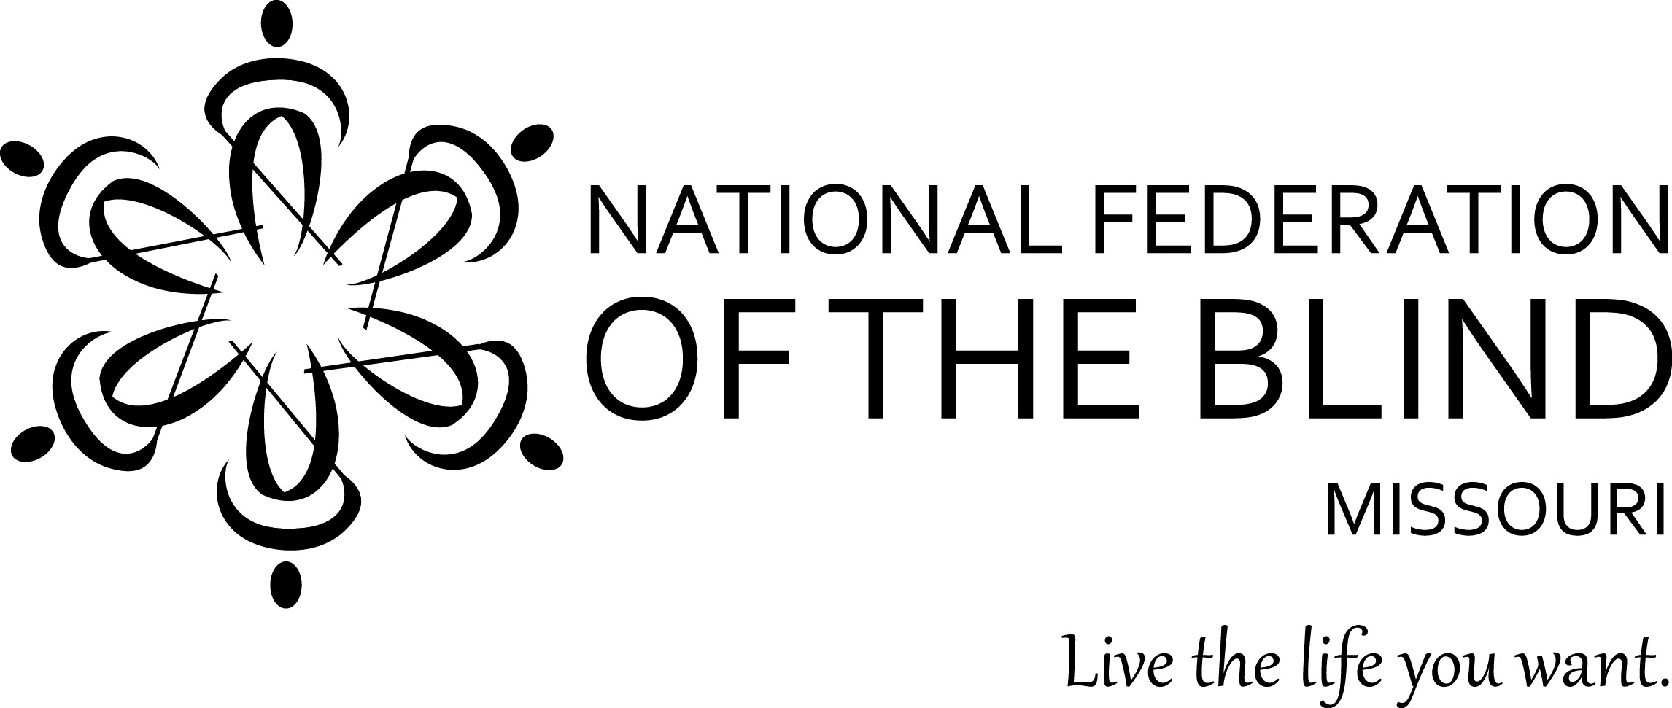

Table of Contents

2023 Presidential Report by Shelia Wright 1

2023 State Convention Resolutions 5

Press Release Regarding Blind Voting Rights. 8

Yes, Virginia, Chapters Can Pass Resolutions
by Daniel Garcia 10

The Pieces of Your Life by Jenny Carmack 12

National Federation of the Blind of Missouri
Mission BEAM Mentor Job Announcement 13

BELL is Back by Jenny Carmack 14

NFB Pledge 15

One Minute Message 15

2023 Presidential Report
By Shelia Wright

In the National Federation of the Blind of Missouri, members are our greatest resource. Most of you are involved in the National Federation of the Blind of Missouri as a member of one of our local chapters or in our at large chapter which we began for members that do not live near a local chapter. Some of you serve on one or more of our NFB statewide committees, and I want to thank you for all you do. If you are ready to get involved or want to take on additional roles, please, reach out to your chapter president or to me and let us know where you want to serve. If you are not sure where you can best serve, please let me know, and we can suggest opportunities that may be a good fit. At any rate, there is a place for you, and when you decide to engage, we, the organized blind of Missouri, will be stronger and your opportunity to gain experience and make a positive difference in your community and beyond will become a reality.

The National Federation of the Blind of Missouri has experienced growth throughout the state over the past year and this is exciting. Our Springfield Chapter has doubled in size and is still growing, and other chapters are bringing in new members every quarter.

Last year during the Presidential Report, you heard about our work to pass the Blind Student’s Rights to Independence, Training, and Education Act (BRITE Act). Shortly after the state convention, we celebrated the passage of the BRITE Act. Later this morning you will hear a report from Kevin Hollinger and Gary Wunder on the importance of the collaboration that occurred to get this bill passed, what we learned from this collaboration, and how the BRITE Act strengthens the Missouri statutes to advocate for the services blind students need.

Wanting to take advantage of all we learned about involving all the stakeholders in the early phase of a bill, we reached out to the Missouri Board of Pharmacy and the Missouri Association of Pharmacists in the fall requesting time on their agenda to speak with them about accessible prescription labels and a solution. We were delighted to be invited to make a presentation to the Missouri Board of pharmacy, and just a few days prior to the meeting, Rep. Michael Stephens filed HB 812, the Accessible Prescription Label Act. Roger Crome and I presented the NFB of Missouri’s concerns, demonstrated several audible solutions, and answered questions. The discussion was positive, and several members of the board indicated they were unaware that such devices and apps existed and expressed their appreciation for the information. Others were more familiar with the topic. We were encouraged because there was acknowledgement that not having access to prescription information is a safety issue; however, they expressed hesitance to go as far as to require every pharmacy to go to the expense that would be required for them to provide the accessible prescription labels. They agreed to talk among themselves to determine their positions and/or what they may be able to undertake. The real outcome has been that we now have an open and ongoing conversation, and regardless of the outcome of the bill, they are working with us to conduct an Accessible Prescription Label Education Campaign.

Sharla Glass from Envision America has been with us all the way and has been most helpful in providing information and drafting the FAQ and responses to questions raised at the House Health and Mental Health hearing on March 6th. A shout out to Sharla who has been with us at this convention. The experience we have gained this year and the improved tools we have developed this year will help us make better presentations when talking with members of the legislature in future meetings/hearings.

Douglas Rider, a blind father of two children, Nicholas (13) and Abigale (11), has faced challenges in his 14-year marriage due to his wife's multiple affairs. In her most recent affair, she decided she wanted to move to Jefferson City and take the children with her. This would have been exceedingly difficult for Douglas because he does not drive, not to mention, he had no interest in giving up custody.

He has always been the primary caretaker of the children. It was only when his wife wanted to move that his blindness became an issue in the custody dispute. Although Douglas’s wife and her legal team have repeatedly asked the Guardian ad litem and the court to consider his blindness, they have thus far considered it irrelevant.

Fortunately, we were able to tell Douglas about the law that was passed to protect the rights of blind and disabled parents. Not only has this been helpful in the eyes of the court, it has been transformational in getting Douglas's attorney to acknowledge that he does have rights that can be defended. While transportation remains a challenge, Douglas has managed to find workarounds to fulfill his parenting duties.

A PDL (pendente lite) hearing was held to determine temporary custody arrangements while the divorce is ongoing. The judge found Douglas to be more credible, which suggests that he views the wife as less trustworthy. This may bode well for Douglas in the upcoming custody decision. Currently he has major custody, and the wife's visitation is limited to weekends and the sharing of holidays.

In September of 2021, our affiliate received a grant to fund a Senior Blind Program. Like so many things, COVID interfered in our getting the program off the ground. Seniors were just not eager to go out in public. Finally, in September 2022, we held our first Senior Retreat at an Air BNB in Kansas City south. We had four participants signed up; however, two had to cancel at the last minute. The two participants that came, learned about several resources such accessible prescriptions and other solutions to manage medications, NFB Newsline, Be My Eyes and Aira, Way Around Tags and other ways to identify clothing, etc., We demonstrated, and they had an opportunity to practice alternative techniques for cooking, cleaning, and other ADL tasks. They were introduced to reading and writing Braille and cane travel techniques. Most of all they had an opportunity to get to know several successful blind adults and had an opportunity to talk with others about their fears, frustrations, and hopes. We hope to build on this experience with these individuals and expand the program to reach newly blind seniors who can benefit from similar experiences. Thank you to Linda Black White and Willa Patterson for being on hand to share their lived experiences with the first Senior Blind Retreat.

In September, Governor Parson issued a proclamation designating October 15 as White Cane Awareness Day and so did the Mayors of Columbia, Jefferson City, Kansas City, St. Louis, and Springfield. I certainly do not want to forget the proclamation from St. Louis County. Our December Blind Missourian also had reports from several of our chapters about their Blind Equality Achievement Month Activities. It will soon be time to start planning for our 2023 Blind Equality Achievement Month and I look forward to seeing the innovative ideas our chapters will launch.

It was great to be Live in Washington, DC once again this year in February. Though we made a lot of good contacts during our virtual seminars, there is nothing like being there for our in-person meetings. Dennis Miller, our Legislative Director, distributed information to our members as soon as it became available and entered all the appointment data into the Washington Seminar portal. Laurice Cason and Seyoon Choi helped with scheduling appointments with their members of Congress. Our Missouri team this year consisted of Laurice Cason (first timer), Amy Wilson (first timer), Seyoon Choi, and veterans Debbie & Gary Wunder. Those that have been to a Washington Seminar will tell you our Washington Seminar is an opportunity to see the Federation in action. Each year the Washington Seminar is the kick-off to our legislative year. It is exciting and energizing. However, it is only the beginning of our legislative year.

During the Washington Seminar, we visited the offices of both Missouri Senators and the Congressional Office of all eight of our members of the House of Representatives. During these meetings we outlined our priorities which were the Websites and Software Applications Accessibility Act, the Medical Device Nonvisual Accessibility Act, and the Blind Americans Return to Work Act. Our National Representative talked about each of these bills earlier this morning. The truth is that these bills are merely concepts right now. The more each of our elected officials in Washington hear your stories and how these bills can help you, the more likely they will be willing to support these bills and turn these bills into acts that will be effective to you and blind Americans across our land. So please call or email when you hear about our calls for action.

Our Jefferson City Seminar was a success this year. For the first time in many years, every chapter was represented, and the number of appointments with legislators made this year’s seminar a tremendous success. Thank you to all who made appointments for those of us who were able to go to Jefferson City and to everyone who walked or wheeled the halls of the Missouri State Capitol. I cannot end this paragraph without thanking those who testified at the hearing for 812 or sat in the hearing room lending your support. It was exciting to see several new witnesses who submitted written testimony. Well, I better move on to the next topic, so Roger will still have something to say tomorrow when I call on him for his Governmental Affairs Report.

Thank you, thank you all for being a part of the National Federation of the Blind of Missouri. With love, hope, and determination we can make dreams come true. Let’s build the National Federation of the Blind of Missouri.

2023 State Convention Resolutions

Resolution 23-01
Regarding Accessible Communication from the Department of Social Services

WHEREAS, the Department of Social Services (DSS) serves people with visual impairments and blindness, all having have the right to access information and services in a manner that is accessible to them; and

WHEREAS, blind people may face challenges in independently accessing information sent by DSS through traditional printed letters because they may require assistance from others to read or interpret the information, which can compromise their privacy and independence; and

WHEREAS, providing information in a form that blind people can read, such as Braille or accessible electronic formats, can enhance their ability to independently access and understand important communications from DSS; and

WHEREAS, Braille and electronic formats are an effective means of communication for blind people, allowing us to access information in a timely and independent manner; and

WHEREAS, accessible communication is a fundamental principle of respect and inclusivity that aligns with the principles of the Americans with Disabilities Act (ADA) and other relevant laws and regulations: Now, therefore,

BE IT RESOLVED by the National Federation of the Blind of Missouri in Convention assembled this 16th day of April, 2023, in the City of St. Louis, Missouri, that the Department of Social Services is strongly encouraged to take the following actions to ensure accessible communication for blind people:

1. Provide all written communications, including letters, notices, and other relevant documents in accessible formats such as Braille, large print, or in an accessible electronic format, this being done upon request from blind people who are registered with DSS or self-identify as blind;

2. Establish and maintain a process for blind people to request accessible formats, including clear instructions on how to make such requests and the timelines for receiving the requested information;

3. Ensure that all DSS staff members are trained and knowledgeable about the importance of accessible communication and the available options for providing information in accessible formats to blind people;

4. Regularly review and update DSS policies, procedures, and communication practices to ensure compliance with accessibility requirements and best practices for providing information in accessible formats to blind people; and

BE IT FURTHER RESOLVED that DSS allocate the necessary resources, including budget and personnel, to implement and sustain the above measures and that it regularly monitor and report on the progress of implementing accessible communication practices for blind people; and

BE IT FURTHER RESOLVED that any policy change resulting from this resolution be circulated to all DSS staff members, posted in prominent locations in DSS offices, placed on the DSS website, and shared with relevant stakeholders to raise awareness about the importance of accessible communication and demonstrate the department's commitment to inclusivity and accessibility for blind people.

Resolution 2023-02
REGARDING HB 510

WHEREAS, House Bill 510 would eliminate the requirement that Blind Pension annual review forms be sent via certified mail among other provisions; and

WHEREAS, similar legislation has been proposed for several years; and

WHEREAS, the bill is currently on the House Informal Calendar, having successfully navigated through the House committee process: Now, therefore,

BE IT RESOLVED by the National Federation of the Blind of Missouri in Convention assembled this 16th day of April, 2023, in the City of St. Louis, that we urge House Speaker Dean Plocher to expeditiously bring this bill up for a vote by the full House; and

BE it further resolved that we encourage the Senate to proceed with all deliberate speed to pass this, once the House transmits the bill to it so that this burdensome requirement can be finally eliminated.

Resolution 23-03
Regarding HB 812 for Accessible Prescription Labels

WHEREAS, House Bill 812 would provide that accessible prescription labels be available for blind people, people with a visual impairment, and other Missourians with a print-reading disability; and

WHEREAS, this bill was heard in committee on March 6, with no further action being taken since then: Now, therefore,

BE IT RESOLVED by the National Federation of the Blind of Missouri in Convention assembled this 16th day of April, 2023, in the City of St. Louis, Missouri, that we urge Committee Chair Mike Stephens to convene an executive session on this vital piece of legislation so that further action may be taken by the House to give all Missourians full access to their prescription information.

Resolution 23-04
Regarding Accessible Kiosks

WHEREAS, retailers such as Hy-Vee, Target, Walmart, Aldi’s, the Kroger family of stores, and others are now widely using self-checkout devices; and

WHEREAS, more and more often the stores are relying solely on the self-checkout devices for customers to make their purchases, without any human beings to assist customers; and

WHEREAS, these devices are not usable by the visually impaired or blind customer because there is no speech output with either a speaker, a headphone jack, or any other method allowing the customer to interface with the machine: Now, therefore,

BE IT RESOLVED by the National Federation of the Blind of Missouri in Convention assembled this 16th day of April, 2023, in the City of St. Louis, Missouri, that we urge the Missouri Grocers Association and the Missouri Association of Retailers to seek a solution to this difficulty for the visually impaired and blind by urging all their members to provide at least one live checker when the retail establishment is open, until the machines can be made fully accessible for every customer.

Here is the press release that the National Federation of the Blind of Missouri sent out on May 1st, 2023 regarding blind voting rights.

For Immediate Release

National Federation of the Blind of Missouri Calls for Equal Voting Rights for the Blind

Kansas City, Missouri (May 1, 2023): The National Federation of the Blind of Missouri is a nonpartisan organization committed to promoting the welfare and rights of the blind and visually impaired, as well as the sighted individuals who support our cause. We are a diverse group, including conservatives, liberals, democrats, republicans, and independents. We are united around many goals, one of which is ensuring the right to vote privately and independently for blind people.

In recent elections, blind voters have faced difficulties in accessing ballot marking devices, which are essential to enable us to vote privately and independently. These devices allow blind people to hear the ballot choices and reflect their choices on a paper ballot by using a keypad with buttons to make their selections. These devices do not count votes but simply mark paper ballots that are then counted by the units that tally votes according to the selections made by each county. Unfortunately, the availability of ballot marking devices has been inconsistent, which is in violation of two federal laws.

The National Federation of the Blind of Missouri and other concerned organizations of the blind have filed complaints with the Department of Justice, urging the federal Attorney General to address this issue. In response, the Department sent election monitors to verify our concerns, but they were turned away with the argument that no one can interfere with Missouri’s election process. The clear implication asserted and reported was that the federal government was trying to do just that. This refusal to observe and address our concerns has left us as victims in a battle framed around state's rights when the real issue is our right to vote with the same secret ballot that others take for granted.

As an organization, we strive to help everyone without regard to their political affiliation. The diversity of our membership, being a cross-section of Missourians, demands it; so too do the laws that grant us limited tax exemptions.

“The right of blind people to vote privately and independently should not be compromised or overlooked in anyone's messaging in their pursuit of higher office,” said Melissa Kane, Chair of the NFB of Missouri’s Accessible voting Committee. “Blind citizens, like all Americans, have a personal stake in the issues that confront our country and the world. It is vital that our right to vote is not overshadowed by philosophical or ideological wars in which we have no part but end up being the victims.”

We call upon every candidate to embrace our right to vote privately and independently based on two simple principles: Voting is a fundamental right and a sacred obligation in our country and because they may well be the beneficiary of our votes. The National Federation of the Blind of Missouri will continue to advocate for the voting rights of the blind and visually impaired, ensuring that our voices are heard in the democratic process.

###

About the National Federation of the Blind

The National Federation of the Blind (NFB), headquartered in Baltimore, is the oldest and largest nationwide organization of blind Americans. Founded in 1940, the NFB consists of affiliates, chapters, and divisions in the fifty states, Washington DC, and Puerto Rico. The NFB defends the rights of blind people of all ages and provides information and support to families with blind children, older Americans who are losing vision, and more. We believe in the hopes and dreams of blind people and work together to transform them into reality. Learn more about our many programs and initiatives at www.nfb.org.

Contact:
Shelia Wright, President
National Federation of the Blind of Missouri
(816) 679-5258
president@nfbmo.org
Yes, Virginia, Chapters Can Pass Resolutions
By Daniel Garcia

In 1897, eight-year-old Virginia O'Hanlon wrote a letter to the editor of the New York Sun newspaper asking a most profoundly important question: Is there a Santa Clause? The answer she received was an unequivocal: Yes, Virginia, there is a Santa Clause. In the same way that many people are unaware of the true existence of Santa Clause, many Federationists may not realize that passing resolutions is not solely the exclusive purview of National and State Conventions. Chapters can (and should) pass resolutions. The Kansas City and Ivanhoe Chapters just did.

The December 2022 issue of the Blind Missourian featured an article I wrote about how the Kansas City Chapter promoted the goals of Blind Equality Achievement Month. In that article I explained that I had contacted the Kansas City Area Transportation Authority (KCATA) about the inaccessibility of the application for the complementary paratransit service. I then received a call from Lewis Lowry, Chief Transportation Officer for the KCATA, and he agreed that the KCATA and the NFB would work to resolve this issue. This conversation led to Mr. Lowry attending our November 12 chapter meeting. In January and February 2023, we attempted to contact the KCATA to continue our conversation about issues of concern to blind Kansas City passengers. Our efforts were unsuccessful, so during the March 18 chapter meeting, we passed a resolution calling on the KCATA to meet with representatives of the NFB of Missouri, Kansas City Chapter. The Ivanhoe Chapter passed a similar resolution during their March 25 meeting. The text of the resolution passed by the Kansas City chapter is below.

As I was writing the draft resolution in February, I was reviewing some old Kansas City Chapter records that have been given to me to sort and upload to our affiliate archive. I was humbled by the realization that what we were about to do on March 18 was nothing novel. The Kansas City Chapter has passed resolutions before. It gives me great satisfaction to know that our chapter is continuing a proud tradition of strong advocacy in Kansas City.

A Resolution Regarding Improving Public Transportation for Kansas City Passengers

WHEREAS, the National Federation of the Blind is the oldest and largest nationwide organization defending the rights of blind Americans; and

WHEREAS, the Kansas City Chapter of the National Federation of the Blind of Missouri is one of two chapters in Kansas City, Missouri that advocates for the rights of blind Kansas Citians; and

WHEREAS, the Kansas City Area Transportation Authority is a bi-state agency responsible for providing public transportation in the Kansas City area; and

WHEREAS, blind Kansas Citians have experienced various problems with public transportations recently including: the inaccessibility of the application for the RideKC Freedom complementary paratransit service, paratransit trips being canceled without the passengers consent, paratransit passengers being picked up after the agreed upon time window to initiate the trip, RideKC Freedom on-demand trips not being honored, shortage of fixed-route bus drivers causing passengers to have to wait for the next regularly scheduled bus, and fixed-route buses not announcing the bus number and route at the bus stop; and

WHEREAS, over the past few months the National Federation of the Blind of Missouri, Kansas City Chapter has repeatedly tried to secure a meeting with Kansas City Area Transportation officials to address these issues and share ideas about how to improve transportation for blind Kansas Citians; and

WHEREAS, our efforts have so far been unsuccessful: Now, therefore,

BE IT RESOLVED by the National Federation of the Blind of Missouri, Kansas City Chapter, assembled this 18th day of March, 2023, that we urge Kansas City Area Transportation Authority Officials to meet with representatives of the National Federation of the Blind of Missouri, Kansas City Chapter, and reengage the Rider Advisory Board; and

BE IT FURTHER RESOLVED that we call upon members of the city council and Mayor Quinton Lucas to renew the Mayor’s Committee for People with Disabilities; and

BE IT FURTHER RESOLVED that the National Federation of the Blind of Missouri, Kansas City Chapter will continue to advocate for improved transportation services in the Kansas City Area by various means such as contacting our elected officials, engaging in public relations to bring media attention, and partnering with other like-minded organizations representing people with disabilities and passengers.
The Pieces of Your Life
By Jenny Carmack

A puzzle comes in a variety of shapes, sizes, number of pieces, and designs. There are also various ways a puzzle can be put together: edges first, top to bottom, by identical colors, etc. One thing that is true about all puzzles is that for them to be successfully completed, all of the pieces must end up correctly connected.

We could say that the journey of our lives is similar to putting a puzzle together, the pieces need to connect in order for successful completion. Sometimes we change paths (or puzzles) or start a new path after traveling on one path for a while (begin a new puzzle). But, in order for one to feel as if they have successfully completed something, all of the pieces have to fit together.

This was the analogy given at the most recent Mission BEAM workshop, “The Pieces of Your Life.” On Saturday, May 6, students and their family members came together to explore the various pathways they may choose upon graduating from high school (college/tech school, training center, transition program, employment, etc.). Students and family members had the opportunity to learn about the various choices: their pros and cons, how they each differ from the high school setting, how to decide which choice is best for the students, statistics related to some of the choices, and the responsibility of the student upon entering their next piece of life. This information was shared with participants in a variety of ways: articles, blogs, checklists, videos, interactive websites, and a panel discussion. We know that students and their families often have different perspectives and questions about what lies ahead for the student, so family members and students were split up for portions of the day; this gave everyone a chance to express their concerns as questions and have genuine conversations. Students and Family members came together during lunch and for the last hour for some group discussion and collaboration.

Based on feedback from all of the participants, the students seemed to really connect with the panelists, and family members seemed to gain a lot from being able to talk with each other. It seems that everyone felt that they had some new and useful information to use when making decisions and had a good foundation for conversations within the family units. Through the surveys and my own personal reflection, I have learned some new ways to make this workshop more interactive while including the same information. This workshop, albeit new and improved, will likely be held again at another time. Thank you to all of the participants and volunteers who made this workshop a success.
National Federation of the Blind of Missouri
Mission BEAM Mentor Job Announcement

Job Title: Mentor for Blind/visually impaired youth

The National Federation of the Blind of Missouri, Mission Beam is looking for successful blind/low vision individuals who are proficient in blindness skills, alternative techniques, and who are interested in empowering youth through this mentorship program. Mentors will guide blind and visually impaired youth as they acquire blindness skills in the areas of: self-advocacy, peer mentoring, independent-living, and career readiness.

Requirements:
*Mentors must have effective communication skills.
* Mentors must be able to spend 5 - 8 hours per month with the assigned
mentee.
* Mentors must be able to travel independently.
* Mentors must have knowledge of the use of accessible technology for the
blind.
*Mentors must be available to meet monthly in a group session facilitated
by the Program Coordinator.

* Mentors must be at least 22 years of age and have at least 2 years of
successful work-based experience.
*Mentors must pass a background check.

Submit application, references, and resume by going to www.nfbmo.org/BEAM

BELL is Back
By Jenny Carmack

Have you heard? The NFB of Missouri BELL Academy is back for a 10th year. Yes, you read that right, this will be the 10th year that Missouri has had the opportunity to hold BELL Academy!!! And that’s not all… BELL will be held in two locations this year, Springfield and St. Louis. What could be more exciting than that?

So, now that I have your attention, you may be wondering, what is BELL and why is it so awesome? Well, I am happy to tell you all about it. BELL (Braille Enrichment for Literacy and Learning) Academy is a two-week program for students ages four to twelve years old. During these two weeks, students get to participate in fun, hands-on activities that help them to enhance their Braille and other non-visual skills. Often times the students are having so much fun, they don’t even realize they are learning. In fact, students report that one of the things they enjoy about BELL is that the lessons/activities are led by blind adults and that they get to make friends with other blind students their age (an opportunity most of them rarely have). Some favorite things students like to do are: play Braille Twister, make tactile pictures, write silly stories, have music time, science experiments, cooking, go on field trips, and the finale of a family presentation. Students are encouraged to be as independent as possible, use their white cane safely when moving around, wear learning shades for some activities, and most of all to have fun while they learn some new things. Do you want to know a secret? Shhh, don’t tell anyone, but sometimes the blind adults learn something too.

So, are you impressed? Intrigued? I hope so. We still have room in both locations for some students, but they may not last long. Don’t worry, it’s easy to claim your student’s spot. Just go to www.nfbmo.org/bell and find the flyer containing the link to register your student. What’s that you say? You don’t have a student and you are not a young child, but you want to participate in this amazing experience. There’s good news, you can still be a part of BELL, just go to www.nfbmo.org/bell and fill out the volunteer application and we will be in touch with you. Now, for those of you who don’t have or know a student, are not able to volunteer, but want to learn about how this summer’s program goes, you’re in luck! Make sure to read the next edition of the Blind Missourian for the BELL Academy wrap up article.

If you have any questions about BELL Academy or other youth programs, please email us at: youth-programs@nfbmo.org.

Pledge of the
National Federation of the Blind

I pledge to participate actively in the efforts of the National Federation of the Blind to achieve equality, opportunity, and security for the blind; to support the policies and programs of the Federation; and to abide by its Constitution.

One Minute Message

The National Federation of the Blind knows that blindness is not the characteristic that defines you or your future. Every day we raise the expectations of blind people, because low expectations create obstacles between blind people and our dreams. You can live the life you want; blindness is not what holds you back.

Board of Directors
National Federation of the Blind of Missouri

Officers:
Shelia Wright, President Jenny Carmack, First Vice President
Daniel Garcia, Second Vice President Becky Boyer, Recording Secretary
Dennis Miller, Corresponding Secretary Carol Coulter, Treasurer

Board Members:
Eugene Coulter Seyoon Choi Janice Grisham
Amy Wilson Randy Carmack Jeff Giffen Svetlana Ehlers President Emeritus, Gary Wunder

Chapter Presidents
Columbia Chapter, Gary Wunder, 573-874-1774
Jefferson City Chapter, Melissa Kane, 573-473-8584
Springfield Chapter, Janice Grisham, 417-761-0253
Kansas City Chapter, Daniel Garcia, 816-621-0902
Lewis and Clark Chapter, St. Louis, Jenny Carmack, 314-239-9776
Mineral Area Chapter, Farmington, Roger Crome, 573-701-8409
Ivanhoe Chapter, Kansas City, Linda Black-White 816-923-7074
Show Me at-large Chapter, meets via Zoom, call Dennis Miller, 660-234-5351

Blind Missourian Editor Carol Coulter
Proofreaders: Shelia Wright, Daniel Garcia and Grace Warn
Read by Elisabeth Coulter

FREE MATTER FOR THE

BLIND AND PHYSICALLY

HANDICAPPED

NFB of Missouri
1504 Furlong Dr.
Columbia, MO 65202

