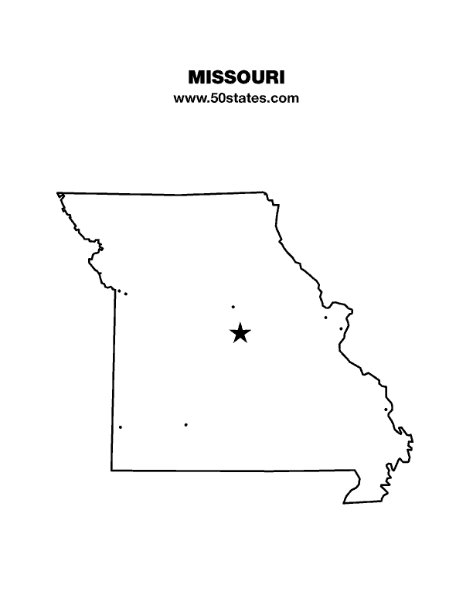
The Blind Missourian
December 2020

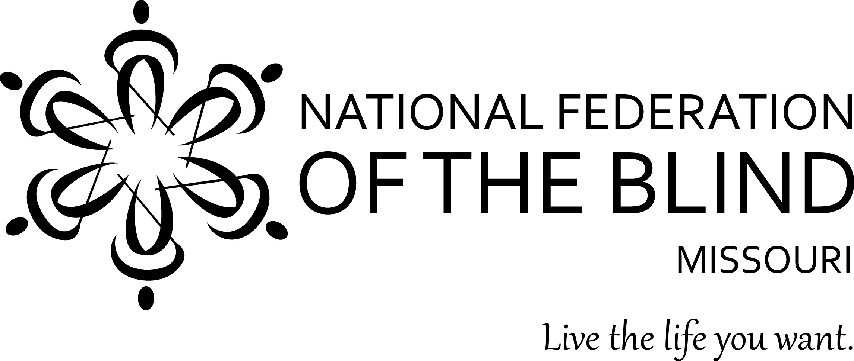

Table of Contents

National Federation of the Blind of Missouri
2021 Scholarship Program by Robin House 1

Personal and Career Development Group by Daniel Garcia 2

White Cane Day Proclamation 3

One Minute Message 4

NFB Pledge 4

2021 State convention information by Gene Coulter 5

National Federation of the Blind of Missouri
2021 Scholarship Program

The National Federation of the Blind of Missouri announces our 2021 Scholarship Program. We will be accepting applications until February 1, 2021. We invite all qualified candidates to apply. Applicants must be legally blind and plan to enroll in a post-secondary institution for the fall of 2021. Applicants should live in Missouri but need not be a member of the National Federation of the Blind. Scholarships begin at $500 and are based on merit. We invite applicants to submit all information and documents online. All application materials must be received by February 1, 2021 either through the online form (found at www.nfbmo.org) or at the email address provided below. Acknowledgment of applications and documents will be sent upon receipt. If you have questions or concerns, please do not hesitate to contact the Scholarship Chair.
A complete application consists of the official application form and a student essay, plus these supporting documents: student transcripts, two letters of recommendation, a letter from an NFB of Missouri Scholarship Committee member, and proof of legal blindness. Please note that letters of recommendation must not be submitted by the applicant but must come directly from the person authoring the recommendation.
In an effective essay the applicant may consider sharing about his or her life in a way that gives the committee insight into him or her. The essay should cover the ways in which one lives successfully as a blind person and describe personal goals for the future. Committee members give the essay a great deal of attention.
In addition to receiving the monetary award, the scholarship recipients will attend the convention of the National Federation of the Blind of Missouri, March 25-28, 2021, at the Doubletree Hotel in Springfield, Missouri. Hotel accommodations, convention registration, and planned meals during the convention will be included. We are also happy to help coordinate transportation to ensure this is not a barrier to our scholarship class. The type of transportation assistance may vary based on where in Missouri the winner resides and the available transportation resources in that community.
Throughout the convention, scholarship winners will have an opportunity to learn about the National Federation of the Blind and network with successful blind people. In addition, final interviews with the Scholarship Committee will aid the committee in determining the scholarship each winner will receive.
You should know that merit scholarships from the National Federation of the Blind go directly to the winner and should not be considered as a similar benefit by Rehabilitation Services for the Blind. Therefore, students can use funds to meet expenses that other funding sources do not cover. Also, merit scholarships are viewed favorably when included on a resume.
The application can be found on the NFB of Missouri website. If you have any questions about the application process, please contact the scholarship chair.
Robin House, Chair Scholarship Committee
National Federation of the Blind of Missouri
Phone: 314-265-6852.
Email: scholarships@nfbmo.org
Web Page: www.nfbmo.org

Personal and Career Development Group Meeting: The Role of Braille in Employment for Blind People
By Daniel Garcia

The NFB of Missouri Personal and Career Development Group holds its meetings on the first Monday of the month which means that the January, 2021 meeting will be on January 4, the birthday of Louis Braille. It was thus not difficult to come up with a topic for the meeting.
During the January 4, 2021 meeting, the Personal and Career Development Group will be discussing the role of Braille in the employment of blind people. Everyone is welcome to come and share how they use Braille at work. We will also have a conversation about how those blind individuals who are not Braille readers can still be productively employed. The meeting will be conducted via the Zoom platform at 8 pm central time. Note that if the January Live Presidential Release runs past 8 pm central time, I will start the meeting ten minutes after the end of that event. Please RSVP by calling me at 816-621-0902 or by sending me an email message to dangarcia3@hotmail.com.
The goal of the National Federation of the Blind of Missouri Personal and Career Development Group is to encourage people to find employment and develop their careers through personal growth strategies. We believe that personal growth leads to career growth. Though it is important to have a good resumé, network, etc., to find work, it is equally important to be confident about yourself and what you can accomplish.

White Cane Day Proclamation document.
The document is on fancy parchment paper surrounded by a black trim.

Office of the Governor

Followed by a gold seal that reads, “THE GREAT SEAL OF THE STATE OF MISSOURI, UNITED WE STAND – DIVIDED WE FALL, SALUS POPULI LEX ESTO MDCCCXX”

State of Missouri,
Governors Proclamation

WHEREAS, the white cane is a simple yet effective tool of independence that contributes to the self-sufficiency of individuals who are blind and visually impaired and symbolizes their ability to achieve a full and independent life and their capacity to work productively in competitive employment; and

WHEREAS, the white cane is a symbol of dignity and determination as well as a tangible reminder that individuals with impaired eyesight are able to go, to move, to be, to compete, and to contribute with all others in society and to lead full, independent and productive lives; and

WHEREAS, established by the National Federation of the Blind, the annual observance of “White Cane Awareness Day” emphasizes the need for all Americans to be aware of the presence of persons with disabilities in our communities and to work together to keep the streets, highways, sidewalks, walkways, public buildings, facilities, and places of public accommodation, amusement, and resort safe and functional to the disability community; and

WHEREAS, the 2020 observance of “White Cane Awareness Day” provides an opportunity for people across the Show-Me State and the nation to renew their dedication to eliminating barriers for people who are blind and visually impaired, and to recognize their value as individuals, employees, and productive members of our communities.

NOW THEREFORE, I Michael L. Parson, GOVERNOR OF THE STATE OF MISSOURI do hereby proclaim October 15, 2020, to be

WHITE CANE AWARENESS DAY

in Missouri and encourage all Missourians to show respect for those who carry the white cane, to honor their many achievements, and to reaffirm our commitment to improving access to basic services and opportunities for persons who are blind and visually impaired.

IN TESTIMONY WHEREOF, I have hereunto set my hand and caused to be affixed the Great Seal of the State of Missouri, in the City of Jefferson, this 23rd day of September, 2020.”

On the bottom left is a somewhat larger gold Missouri State Seal with a red ribbon attached and on the bottom right is Governor Michael Parson’s signature and below his is Secretary of State Jay Ashcroft’s signature.

One Minute Message

The National Federation of the Blind knows that blindness is not the characteristic that defines you or your future. Every day we raise the expectations of blind people, because low expectations create obstacles between blind people and our dreams. You can live the life you want; blindness is not what holds you back.

Pledge of the
National Federation of the Blind

I pledge to participate actively in the efforts of the National Federation of the Blind to achieve equality, opportunity, and security for the blind; to support the policies and programs of the Federation; and to abide by its Constitution.

59th Annual Convention of the National Federation of the Blind of Missouri
Doubletree Hotel, 2431 North Glenstone Avenue, Springfield, MO 417-831-3131
March 25-28, 2021 pre-register online at www.NFBMo.org.

We are excited to have two great chapters hosting our convention this year as the Show-Me and Old Drum chapters are combining together to make this convention memorable. The Show-Me Chapter would like to welcome our Federation family to Springfield. We are so glad you could join us this year. The Show-Me Chapter is the at-large chapter of the NFB of Missouri. We have members from all over the state who meet monthly via conference call. We appreciate the opportunity to co-host the 2021 convention of the National Federation of the Blind of Missouri.
The Old Drum Chapter is our chapter in Warrensburg, located in west central Missouri. Recently the Old Drum Chapter celebrated their fifth anniversary. The name Old Drum comes from a court case about a dog named Old Drum where the term “man’s best friend” was first used.
Come to the Doubletree Hotel with room rates of $102 a night (plus 14.1% tax). To make reservations call 417-831-3131. The hotel is pet friendly and has an indoor/outdoor swimming pool, fitness center, ATM, free Wi-Fi, new parking garage, and complimentary airport transportation. This is a smoke-free hotel. Hotel check-in is 3:00 PM and check-out is at noon.
Houlihan’s opens at 11:00 AM daily and closes at 12:00 AM Friday and Saturday and 11:00 PM Sunday through Thursday. Gracie’s is open daily for breakfast from 6:00 to 10:00 AM Monday through Friday and 7:00 to 11:00 AM Saturday and Sunday. Room Service is available from 7:00 AM to 11:00 PM.
Attention anyone looking for a good deal this year we are introducing the Frugal Federationist Package for $55 if bought by March 18. This includes convention registration, a banquet ticket, and a Saturday lunch ticket, saving you up to 25%. Do not miss the banquet. We will also have a planned lunch for Friday and Saturday, and the Prayer Breakfast Sunday. After March 18, the cost for registration and all meals will increase. There will be few, if any, tickets available for Friday lunch on site. Registration will be open from 8:15 to 8:45 AM and 5:00 to 7:00 PM Friday, and 8:00 to 8:25 AM Saturday. Hospitality will be Friday from 5:00 PM to 10:00 PM.
We will be offering the Kid’s Zone for children in need of supervised care again this year. There is no cost for children who are registered for the convention. See the information on the following pages for details on Kid’s Zone, children’s meal prices, and exhibitor/sponsorships. To donate door prizes, please contact Door Prize Chair Amy Wilson, Phone: 660-441-1907.
National Federation of the Blind of Missouri
59th Annual Convention, March 25-28, 2021

Please use one form per residence. Several registrations may be combined on one check if they are sent together. Sorry no refunds unless the event is cancelled.
Registrant Name: ________________________________________________
Second registrant: _________________________________
Street Address: __________________________, Apt.: ________
City: ______________________, State: ____, Zip Code: _________
Phone Number: ______________, Email: _____________________
Select preferred agenda format: __ Braille, ___ Print, ___ Electronic
Desired Blind Missourian format: ___Print, ___Email, ___Thumb Drive, __None
Desired Braille Monitor format: ___Print, ___Email, ___Thumb Drive
Select the items or events that you would like to purchase below:
Frugal Federationist Package: prior to March 18, 2021
Number of Packages: ___ at $55.00 Total: $______
*Convention Registration: Preregistration prior to March 18, 2021
Number of registrants: ___ at $15.00 Total: $______
Annual Banquet: ____ tickets needed at $35.00 Total: $______
Friday Luncheon: ____ tickets needed at $15.00 Total: $______
Saturday Luncheon: ____ tickets needed at $20.00 Total: $______
Prayer Breakfast: ____ tickets needed at $12.00 Total: $______
Total amount enclosed: $______
*For registrations postmarked after March 18, 2021 please add $5 each for Friday lunch, banquet and $3 for prayer breakfast. Add amounts on all forms enclosed and make your check payable to: NFB of Missouri. Please mail to: Carol Coulter, 1504 Furlong Drive, Columbia, MO 65202.
National Federation of the Blind of Missouri
Convention Children’s Registration Form and Kid’s Zone Request
March 27-28, 2021

We will be offering childcare in the Kid’s Zone for those children in need of supervised care. There is no additional cost for children who are registered for the convention, see the form below to register. Care will be provided on Saturday during the morning and afternoon sessions, the evening banquet until 9:00 PM, and the Sunday morning session which will adjourn at 12:00 PM. Meals are not provided in the Kid’s Zone so parents need to make arrangements to feed their children. Important: Parents wanting care for their children must send this request on or before March 5, 2021. Payment for pre-registration and meals also needs to be received by March 5, 2021. You should mail it along with payment to the address below. Payments can be mailed or made at www.nfbmo.org. Meals and registration purchased after March 5, 2021 will cost an additional $5.00 each.
Name of Parent or Guardian: _____________________
Address: ________________________________________
City, State, Zip: ________________________________
Cell Phone: _______________ Home Phone: ________________
Names and Ages of Children: ________________________________________
__________________________________________________________________Special Concerns: __________________________________________________________________Are the above named children in need of services in the Kid’s Zone?_____
Number of registrants: ___ at $10.00 Total: $______
Annual Banquet: ____ tickets needed at $20.00 Total: $______
Friday Luncheon: ____ tickets needed at $10.00 Total: $______
Saturday Luncheon: ____ tickets needed at $10.00 Total: $______
Prayer Breakfast: ____ tickets needed at $12.00 Total: $______
Total amount enclosed: $______
Mail form and check made payable to NFB of Missouri to: Carol Coulter, Treasurer, 1504 Furlong Drive, Columbia MO 65202.
National Federation of the Blind of Missouri
Convention Sponsorship and Exhibitor Registration March 26, 2021

We are pleased to offer the opportunity for companies and organizations to either exhibit or sponsor our 2021 convention. This year we will be at the Doubletree by Hilton, 2431 North Glenstone, Springfield, MO from March 26-28. Exhibits will be open on Friday, March 26 from 2:00 pm to 10:00 pm. Below is the registration form including information on sponsorships. Forms must be returned by March 18.

Name of Organization: _____________________ Phone: __________________

Address: _____________________________________________

Items exhibiting: ___________________ Email: ___________________

Exhibits:
____ $35 for exhibit table only
____ fee waved NFB Chapter exhibit

Sponsorships:
____ Bronze $100 includes exhibit table and 25-word informational message in agenda.
____ Silver $250 includes exhibit table, 50-word informational message in agenda. and thank you at opening ceremony and banquet.
____ Gold $500 includes exhibit table 50-word informational message in agenda, presentation on the agenda, and thank you at opening ceremony and banquet.
____Diamond $1,000 same as Gold but also includes two free banquet tickets.

Make checks payable to NFB of Missouri and mail to: Carol Coulter, Treasurer 1504 Furlong Drive, Columbia, MO 65202

Board of Directors
National Federation of the Blind of Missouri

Officers:
Shelia Wright, President Melissa Kane, First Vice President
Jenny Carmack, Second Vice President Becky Boyer, Recording Secretary
Daniel Garcia, Corresponding Secretary Carol Coulter, Treasurer

Board Members:
Eugene Coulter Roger Crome Robin House
Amy Wilson Chris Tisdal Dacia Cole
Jeff Giffen President Emeritus, Gary Wunder

Chapter Presidents
Columbia Chapter, Gary Wunder, 573-874-1774
Old Drum Chapter, (Warrensburg) Amy Wilson, 660-441-1907
Jefferson City Chapter, Rita Lynch, 573-634-3865
Springfield Chapter, Becky Boyer, 417-771-9022
Kansas City Chapter, Daniel Garcia, 816-505-5520
Lewis and Clark Chapter, (St. Louis) Chris Tisdal, 314-440-1684
Mineral Area Chapter, (Farmington) Roger Crome, 573-701-8409
Show-Me State Chapter, (meets via conference call) Dennis Miller, 660-234-5351

Blind Missourian Editor Carol Coulter
Proof Readers Helen Stevens, Shelia Wright, and Gary Wunder
Read by Elisabeth Coulter

FREE MATTER FOR THE

BLIND AND PHYSICALLY

HANDICAPPED

NFB of Missouri
1504 Furlong Dr.
Columbia, MO 65202

