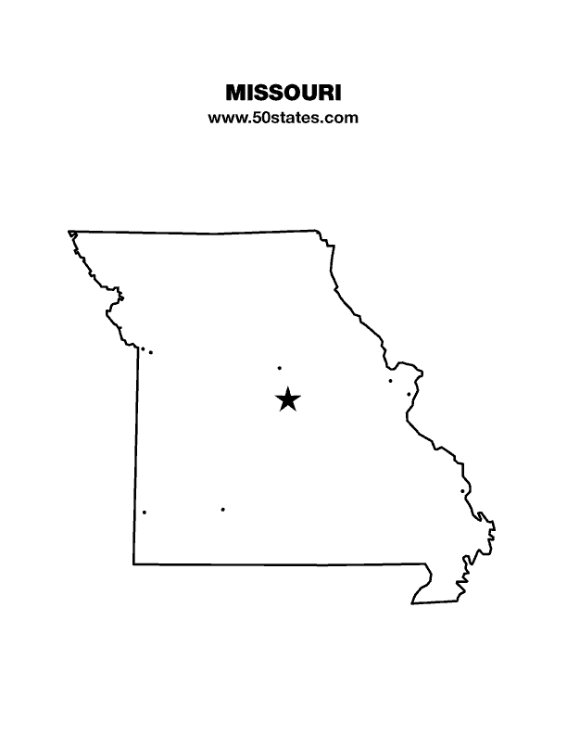
The Blind Missourian
December 2021

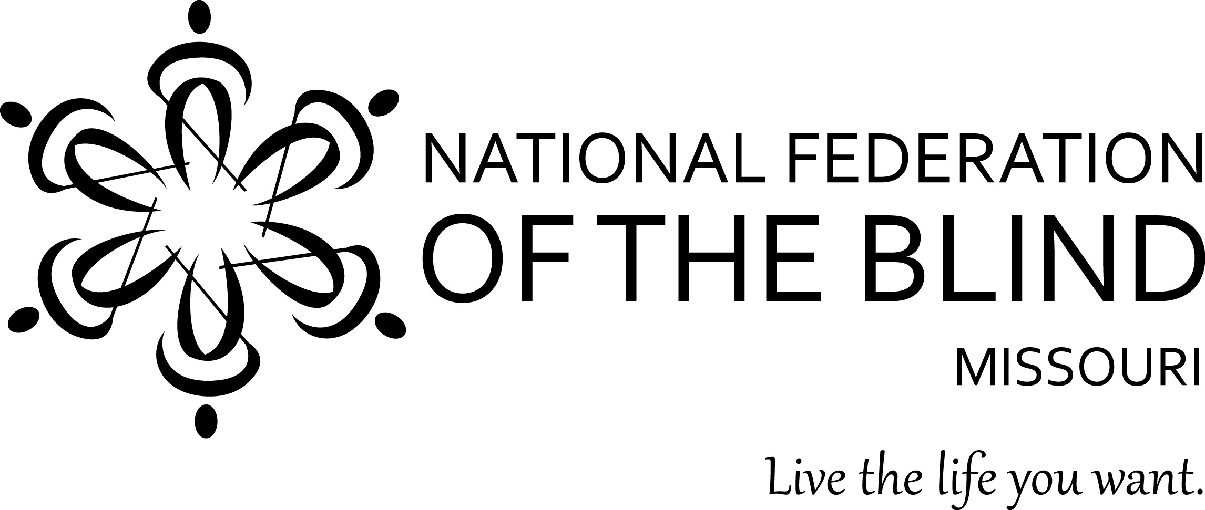

Table of Contents

White Cane Awareness Day Proclamation
Signed by Carrie Tergin, Mayor of the City of Jefferson 1

NFB of Jefferson City Observes Blind Equality
Achievement Month by Rita Lynch 2

Columbia Chapter Recognizes Blind Equality
Achievement Month by Gary Wunder 3

Kansas City Celebrates Blind Equality
Achievement Month by Daniel Garcia 3

Our Commitment to Diversity, Equity, and Inclusion
by Jo Grove 4

Blessed by a Century of Life, and Bringing a Blessing
to Those One Hundred Years by Gary Wunder 5

Chapter Election Results 7

National Federation of the Blind of Missouri
2022 Scholarship Program by Robin House 7

2022 State Convention packet by Eugene Coulter 9

One Minute Message

The National Federation of the Blind knows that blindness is not the characteristic that defines you or your future. Every day we raise the expectations of blind people, because low expectations create obstacles between blind people and our dreams. You can live the life you want; blindness is not what holds you back.

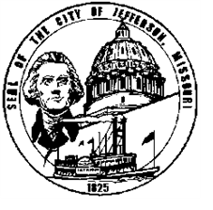
Proclamation

Whereas, the white cane is a simple yet effective tool of independence that contributes to the self-sufficiency of individuals who are blind and visually impaired and symbolizes their ability to achieve a full and independent life and their capacity to work productively in competitive employment; and

Whereas, the white cane is a symbol of dignity and determination as well as a tangible reminder that individuals with impaired eyesight are able to go, to move, to be, to compete and to contribute with all others in society and to lead full, independent and productive lives; and

Whereas, established by the National Federation of the Blind, the annual observance of "White Cane Awareness Day" emphasizes the need for all Americans to be aware of the presence of persons with disabilities in our communities and to work together to keep the streets, highways, sidewalks, walkways, public buildings and facilities, and places of public accommodation, amusement, and resort safe and functional to the disability community; and

Whereas, the 2021 observance of "White Cane Awareness Day" provides an opportunity for people across our Capital City, the State and the nation to renew their dedication to eliminating barriers for persons who are blind and visually impaired and to recognize their value as individuals, employees, and productive members of our communities.

Now, Therefore, I, Carrie Tergin, Mayor of the City of Jefferson, do hereby proclaim October 15, 2021 as

White Cane Awareness Day

throughout the city and encourage all citizens to show respect for those who carry the white cane, to honor their many achievements, and to reaffirm our commitment to improving access to basic services and opportunities for persons who are blind and visually impaired.

____________________________
Mayor
Attest:
____________________________
Deputy City Clerk
NFB of Jefferson City Observes Blind Equality Achievement Month
By Rita Lynch

Our chapter members have been busy in October with the many public relations activities in observing the month as Blind Equality Achievement Month. Our well-planned annual walk-a-thon on October 3 was very successful. It turned out to be a beautiful day, not too hot or too cold and no problem with winds or rain. The proceeds raised were one of our best in the thirty-three years that we have held this fundraising activity. Our local television station, KRCG, TV was present and covered the event. The participants followed the Bagpiper, Dana DeWeese, a couple times around the lake. We appreciate so much everyone’s help in making this a truly enjoyable and very productive event.

We had revised the proclamation that had been drafted and signed by our Governor to fit our city and asked our Mayor, Carrie Tergin to sign it, and she did.

Carolyn Patterson, our latest chapter webpage manager is new at the job, but has been working on keeping our chapter webpage current. Thank you, Carolyn! Thanks also to Nina Theroff who has been busy posting to our chapter Facebook page with pictures of members on the job, exhibiting hobbies, and other various activities of daily life. Nina, we much appreciate your time and dedication! Otto Jespersen, our newest member has been producing public service announcements and has already provided several to our local television station. Thank you so much, Otto.

We are happy to report that State Representative Dave Griffeth, who represents the west side of our city, was invited to our October chapter meeting. He did attend and agreed to sponsor legislation to change the wording in the State Statutes to remove the wording, “certified mail” and replace it with “regular mail” relating to sending out Blind Pension renewals. He plans to ask Representative Bridgett Walsh Moore, who sponsored this bill, HB 117, last session to co-sponsor the bill with him. He said he would get it prefiled, and feels it will go well. We appreciate his being willing to help us get this change made.

We are planning a chapter Christmas party on Sunday, December 12. We thank Sue Tussey for volunteering to find a meeting place to hold this activity. The Capital Shrine Club building which is centrally located has now been reserved for our Christmas party.

Sue also worked on finding a meeting place for the January 29 State Board Meeting which our state board voted to hold here and to be hosted by our chapter. We are happy to report that we have reserved a very nice place at no cost to hold this meeting. The Clydesdale Room is a community room owned by the N H Sheppard Distributers and is located at 2300 St. Mary’s Blvd. We want to wish everyone a very blessed and enjoyable Thanksgiving and Christmas season and all the best in the New Year!

Columbia Chapter Recognizes Blind Equality Achievement Month
By Gary Wunder

The Columbia Chapter held a Zoom Seminar on the rights of parents who are blind and showed the video created to highlight the problems faced by Blake Sennett and Erika Johnson. We also talked about how to better inform blind parents before they have problems and the ways we work on enhancing skills where we who are blind do need to learn and perfect special techniques.

Though we’d like to have had a hundred people attend, we had ten, but that is ten more than if we hadn’t made the effort, and the discussion was very informative. We cannot save every starfish, but that is no excuse not to save the ones we can.

Kansas City Celebrates Blind Equality Achievement Month
By Daniel Garcia

Meet the Blind Month has been renamed Blind Equality Achievement Month. During this month we remember our history, advance equality, and celebrate achievement. The Kansas City Chapter of the NFB of Missouri observed Blind Equality Achievement Month during our annual Walk for Independence which was held on Saturday, October 2, at Loose Park. Rain had been forecast for that day, but we instead had a beautiful sunny day with a temperature of 72 degrees. In attendance, we had nine members of the Kansas City Chapter and seven members of the Johnson-Wyandotte Chapter of the NFB of Kansas which demonstrates that there is no such thing as a border war in the NFB. After a few brief remarks by Kansas City Chapter President Daniel Garcia and Johnson-Wyandotte Chapter President Tom Anderson, we walked around the park, and as we exercised our bodies, we became energized about our continuing mission to bring equality, opportunity, and security for the blind. The walk also allowed us the opportunity to raise funds for the programs of the NFB and to socialize with fellow chapter members, many of whom we had not seen in quite a while due to the COVID19 pandemic.

Our Commitment to Diversity, Equity, and Inclusion
By Jo Grove

The Diversity, Equity, and Inclusion Committee was formed in 2020 by President Shelia Wright. The committee is designed to assist in assuring that an environment of equal treatment and inclusivity for all members exists in the Missouri Affiliate. The Missouri Diversity, Equity, and Inclusion Committee (DEI) has developed the following mission statement to guide the NFB of Missouri, including all of our chapters and divisions, going forward.

Mission: The Diversity, Equity, and Inclusion Committee, of the Missouri Affiliate of the National Federation of the Blind works to facilitate diversity and inclusiveness by fostering a welcoming environment with trust, care, and empathy for all with no exceptions.

Diversity can be briefly defined as those characteristics that make up a person’s identity. Inclusion can be defined as being a part of a group or the norm is a given culture or community.
Equality means each individual or group of people is given the same resources or opportunities. Equity recognizes that each person has different circumstances and allocates the exact resources and opportunities needed to reach an equal outcome.

Intersectionality is the point at which all of the descriptors of a given individual intersect or combine to identify that individual.

Providing a safe and welcoming environment for all current and prospective members is the goal of the Missouri Affiliate. Please feel free to contact any committee member with any ideas, questions, or comments. All information is kept in strict confidence.

Committee Members: Jo Grove, Chair, jogrove08gm@ail.com, phone: 314-320-5957; Brittany Berk, Linda Black-White, Melissa Kane, Dennis Miller,
Roman Solano, Christopher Tisdal, Therese Vercellone, Tony Waterhouse-Leal, Jeremiah Wells, and Shelia Wright, Ex Officio/ President

Blessed by a Century of Life, and Bringing a Blessing
to Those One Hundred Years
By Gary Wunder

One of the benefits of belonging to the National Federation of the Blind is getting to meet so many people and coming to know them well enough to feel blessed. We often observe this as the transition from acquaintance to friend to Federation family, and how apt that is in this situation.

One such person for me has been Helen Parker, someone I suspect I met in the 1990s. Lots of folks tell me that they are tired of the inspiration porn that surrounds blind people, but I'm going to admit straight up that I found Helen Parker an inspiration, and I hope that I am able to live one hundred years as she did and in the way that she did.

Helen was not only the long-time president of our South-Central Chapter, but she was an avid book reader and a wonderful letter writer. Every year at Christmas we got a generalized letter that she wrote to all of the people that she loved, but in addition to that, we got a separate letter that was specific to how we were doing and the things that we might know about her that others did not. She would always sign her letter love, Helen – OBW and then let us know that OBW was for old blind woman.

When I met Helen, she must have been somewhere in her middle to late 70s. You wouldn't have known it from her activity level. She was involved in hosting lots of meetings with friends, going to the gymnasium, and maintaining time at the public swimming pool several days a week. She played the violin and used it to do fundraising for the chapter and for her church. Sometimes she would play without any charge “for the old folks, don’t ya know.” Helen made trips across the country to visit her seven children. Her husband died early, leaving Helen to do much of the child raising as a single parent. One of those children went to work for NASA and was involved in the moon landing. She also attended several of the national conventions and always made prominent notes about it in her Christmas letter that went to everyone.
Helen Parker was kind, competent, and yet humble. I'm not sure it gets any better than that. What a welcomed addition she must be to those who have won the reward of heaven by living a life of service, being grateful for that life, and praising God for granting it. I look forward to more letters from the OBW, but when we meet again, I think I'm going to avail myself of the swimming pool as well.

Recently I saw the following poem in the newsletter of the NFB of Kansas. Given Helen was born on April 15 of 1921 and died on September 8, 2021, I can envision her making this kind of poetic prayer request:

Wishful Thinking
By Pila Mahoney

Today, dear Lord, I am 90 years old and there is much I haven't done,
So, would you let me live some more ... until I am 91?
But then if I have not finished all the things I want to do,
would you let me stay awhile, say ... until I am 92?
So many places I would like to go so much,
much more to see, would you manage then, O Lord, to make me 93?
The world is changing so very fast,
much remains in store and I know you would understand why I would like to make it 94!
And, if at 94, you would grant I am still alive,
would you be very nice indeed, should I remain till 95!
You know, dear Lord, my many errors, things I need to fix ...
So, to make amends, I would dearly love to stick to 96!
I know how much it means to ask.
How great it is in heaven, but your earth is sweet and one more year would give me 97!
I know by then that I will be old and slow and late,
even so, it would mean a lot to be around at 98!
I hope by then to understand, and have given you more time,
So, if would open up your door I will leave at 99!

Chapter Election Results

The following chapters held their elections, and here are the new officers and board members for 2022. Congratulations to everyone.

Jefferson City Chapter: President, Chris Griggs; Vice-President, Nina Theroff;
Secretary, Carolyn Patterson; Treasurer, Eric Meister;
Board Members: Kathy Hurley, Rick Elgin, and Sue Tussey.

Lewis and Clark Chapter: President, Jenny Carmack; Vice President, Christopher Tisdal; Secretary, Stephanie McDowell; Treasure, Randy Carmack; board member, Jo Grove

Old Drum: President, Kayla Myers; Vice president, Trung Arechiga-Vo;
Secretary, Amy Wilson; Treasurer, Kira Arechiga-Vo; Board Member, Amiah Washington

National Federation of the Blind of Missouri
2022 Scholarship Program
By Robin House

The National Federation of the Blind of Missouri announces our 2022 Scholarship Program. We will be accepting applications until February 1, 2022. We invite all qualified candidates to apply. Applicants must be legally blind and plan to enroll in a post-secondary institution for the fall of 2022. Applicants should live in Missouri, but need not be a member of the National Federation of the Blind. Scholarships begin at $500 and are based on merit. We invite applicants to submit all information and documents online. All application materials must be received by February 1, 2022, either through the online form (found at www.nfbmo.org) or at the email address provided below. Acknowledgment of applications and documents will be sent upon receipt. If you have questions or concerns, please do not hesitate to contact the Scholarship Chair.

A complete application consists of the official application form and a student essay, plus these supporting documents: student transcripts, two letters of recommendation, a letter from an NFB of Missouri Scholarship Committee member, and proof of legal blindness. Please note that letters of recommendation must not be submitted by the applicant, but must come directly from the person authoring the recommendation.

In an effective essay the applicant may consider sharing about his or her life in a way that gives the committee insight into him or her. The essay should cover the ways in which one lives successfully as a blind person and describe personal goals for the future. Committee members give the essay a great deal of attention.

In addition to receiving the monetary award, the scholarship recipients will attend the convention of the National Federation of the Blind of Missouri, March 31-April 3, 2022, at the Doubletree Hotel in Springfield, MO. Hotel accommodations, convention registration, and planned meals during the convention will be included. We are also happy to help coordinate transportation to ensure this is not a barrier to our scholarship class. The type of transportation assistance may vary based on where in Missouri the winner resides and the available transportation resources in that community.

Throughout the convention, scholarship winners will have an opportunity to learn about the National Federation of the Blind and network with successful blind people. In addition, final interviews with the Scholarship Committee will aid the committee in determining the scholarship each winner will receive.

You should know that merit scholarships from the National Federation of the Blind go directly to the winner and should not be considered as a similar benefit by Rehabilitation Services for the Blind. Therefore, students can use funds to meet expenses that other funding sources do not cover. Also, merit scholarships are viewed favorably when included on a resume.

The application can be found on the NFB of Missouri website. If you have any questions about the application process, please contact the scholarship chair.
Robin House, Chair
Scholarship Committee
National Federation of the Blind of Missouri
Phone or Text: 314-265-6852.
Email: scholarships@nfbmo.org or Robin@mindsrealm.net
Web Page: www.nfbmo.org

60th Annual Convention of the National Federation of the Blind of Missouri
Doubletree Hotel, 2431 North Glenstone Avenue, Springfield, MO 417-831-3131
March 31-April 3, 2022, pre-register online at www.NFBMO.org

We would like to welcome you to Springfield which is the birth place of Route 66, Bass Pro Shops, Cashew Chicken, and the NFB Springfield Chapter. At our 2022 convention, the NFB Missouri Affiliate will be celebrating our 60th Anniversary. In honor of our affiliate’s Diamond Anniversary, there will be some special guests and a few surprises. We hope you come and make new friends, but also reminisce with old buddies. We want to let everyone sparkle and shine during this Diamond Anniversary. The old saying goes Diamonds last forever, and so does our affiliate.

Come to the Doubletree Hotel with room rates of $102 a night (plus 14.1% tax). To make reservations, call 417-831-3131 before March 17. The hotel is pet friendly and has an indoor/outdoor swimming pool, fitness center, ATM, free Wi-Fi, new parking garage, and complimentary airport transportation. This is a smoke-free hotel. Hotel check-in is 3:00 PM and check-out is at noon.

Houlihan’s opens at 11:00 AM daily and closes at 11:00 PM Friday and Saturday and 10:00 PM Sunday through Thursday. Gracie’s is open daily for breakfast. Room Service is available from 7:00 AM to 10:00 PM.

Attention anyone looking for a good deal; this year we have the Frugal Federationist Package for $55 if bought by March 22. This includes convention registration, a banquet ticket, and a Saturday lunch ticket, saving you up to 25%. We will also have a planned lunch for Friday and Saturday, and the Prayer Breakfast Sunday. After March 22 the cost for registration and all meals will increase. There will be few tickets available for Friday’s lunch on site. Registration will be open from 8:15 to 8:45 AM and 5:00 PM to 7:00 PM Friday, and 8:00 to 8:25 AM Saturday. Hospitality will be Friday from 5:00 PM to 10:00 PM.

We will be offering the Kid’s Zone for children in need of supervised care. There is no cost for children who are registered for the convention. See the information on the following pages for details on Kid’s Zone, children’s meal prices, and exhibitor/sponsorships. To donate door prizes, please contact Chairs Carolyn McGee and Gary Horchem; Gary’s phone number is 417-353-7493.

National Federation of the Blind of Missouri
60th Annual Convention, March 31-April 3, 2022

Please use one form per residence. Several registrations may be combined on one check if they are sent together. Sorry No refunds unless the event is cancelled.
Registrant Name: ________________________________________________
Second registrant: _________________________________
Street Address: __________________________, Apt.: ________
City: ______________________, State: ____, Zip Code: _________
Phone Number: ______________, Email: _____________________
Select preferred agenda format: __ Braille, ___ Print, ___ Electronic

Select the items or events that you would like to purchase below:
Frugal Federationist Package: prior to March 22, 2022
Number of Packages: ___ at $55.00 Total: $______
*Convention Registration: Preregistration prior to March 22, 2022
Number of registrants: _____at $15.00 Total: $______
*Annual Banquet: ____tickets needed at $35.00 Total: $______
*Friday Luncheon: ____ tickets needed at $15.00 Total: $______
*Saturday Luncheon: ____ tickets needed at $15.00 Total: $______
*Prayer Breakfast: ____ tickets needed at $12.00 Total: $______

Total amount enclosed: $______

*For forms postmarked after March 22, 2022, please add $5 each for registration, lunches, banquet and $3 for prayer breakfast. Add amounts on all forms enclosed and make your check payable to: NFB of Missouri. Please mail to: Carol Coulter, 1504 Furlong Drive, Columbia, MO 65202.

National Federation of the Blind of Missouri Convention
Children’s Registration Form and Kid’s Zone Request
April 2-3, 2022

We will be offering childcare for those children of parents who are registered for the convention in need of supervised care. There is no additional cost for children who are registered for the convention, see the form below to register. Care will be provided during all general sessions and the evening banquet until 9:00 PM. Meals are not provided in the Kid’s Zone, so parents need to make arrangements to feed their children. Important: Parents wanting care for their children must send this request along with payment for registration and meals on or before March 11, 2022. Mail it along with payment to the address below. Note: for children not needing childcare, payments for pre-registration and meals must be received by March 22. Payments can be mailed or made at www.nfbmo.org. Meals and registration purchased after March 22, 2022, will cost an additional $5.00 each.
Name of Parent or Guardian: _____________________
Address: ________________________________________
City, State, Zip: ________________________________
Cell Phone: _______________ Home Phone: ________________
Names and Ages of Children: ________________________________________
__________________________________________________________________Special Concerns: __________________________________________________________________Are the above named children in need of services in the Kid’s Zone? _____
Number of registrants: ___ at $10.00 Total: $______
Annual Banquet: ____ tickets needed at $20.00 Total: $______
Friday Luncheon: ____ tickets needed at $10.00 Total: $______
Saturday Luncheon: ____ tickets needed at $10.00 Total: $______
Prayer Breakfast: ____ tickets needed at $6.00 Total: $______
Total amount enclosed: $______
Mail form and check made payable to NFB of Missouri to: Carol Coulter, Treasurer, 1504 Furlong Drive, Columbia MO 65202.
National Federation of the Blind of Missouri Convention
Sponsorship and Exhibitor Registration April 1, 2022

We are pleased to offer the opportunity for companies and organizations to either exhibit or sponsor our 2022 convention. This year we will be at the Doubletree by Hilton, 2431 North Glenstone, Springfield, MO from April 1-3. Exhibits will be open on Friday, April 1 from 1:00 PM to 9:00 PM. Below is the registration form including information on sponsorships. Forms must be returned by March 22.

Name of Organization: _____________________ Phone: __________________

Contact person: _______________________ Email: ___________________

Address: _____________________________________________

Items exhibiting: __________________ ___________________

Exhibits:
____ $35 for exhibit table only
____ fee waved NFB Chapter or division exhibit

Sponsorships:
____ Bronze $100 includes exhibit table, 25-word informational message in agenda, and a mention on the www.NFBMO.org State Convention Page until April 11, 2022.
____ Silver $250 includes exhibit table, 60-word informational message in agenda, a thank you at opening ceremony and banquet, and a mention on the www.NFBMO.org State Convention Page until April 11, 2022.
____ Gold $500 includes exhibit table, 100-word informational message in agenda, a thank you at opening ceremony and banquet, and a mention on the www.NFBMO.org Home Page and State Convention Page until April 11, 2022.
____Diamond $1,000 same as Gold, but also includes two free banquet tickets.

Make checks payable to NFB of Missouri and mail to: Carol Coulter, Treasurer 1504 Furlong Drive, Columbia, MO 65202.
Board of Directors
National Federation of the Blind of Missouri

Officers:
Shelia Wright, President Melissa Kane, First Vice President
Jenny Carmack, Second Vice President Becky Boyer, Recording Secretary
Daniel Garcia, Corresponding Secretary Carol Coulter, Treasurer

Board Members:
Eugene Coulter Dennis Miller Robin House
Amy Wilson Chris Tisdal Randy Carmack
Jeff Giffen President Emeritus, Gary Wunder

Chapter Presidents
Columbia Chapter, Gary Wunder, 573-874-1774
Old Drum Chapter, Warrensburg, Amy Wilson, 660-441-1907
Jefferson City Chapter, Rita Lynch, 573-634-3865
Springfield Chapter, Carolyn McGhee, 573-673-7904
Kansas City Chapter, Daniel Garcia, 816-505-5520
Lewis and Clark Chapter, St. Louis, Chris Tisdal, 314-440-1684
Mineral Area Chapter, Farmington, Roger Crome, 573-701-8409
Show Me State Chapter, meets via conference call, Dennis Miller, 660-234-5351
Ivanhoe Chapter, Kansas City, James White 816-923-7074

Blind Missourian Editor Carol Coulter
Proof Readers: Shelia Wright, Daniel Garcia and Grace Warn
Read by Elisabeth Coulter

Pledge of the
National Federation of the Blind

I pledge to participate actively in the efforts of the National Federation of the Blind to achieve equality, opportunity, and security for the blind; to support the policies and programs of the Federation; and to abide by its Constitution.

FREE MATTER FOR THE

BLIND AND PHYSICALLY

HANDICAPPED

NFB of Missouri
1504 Furlong Dr.
Columbia, MO 65202

