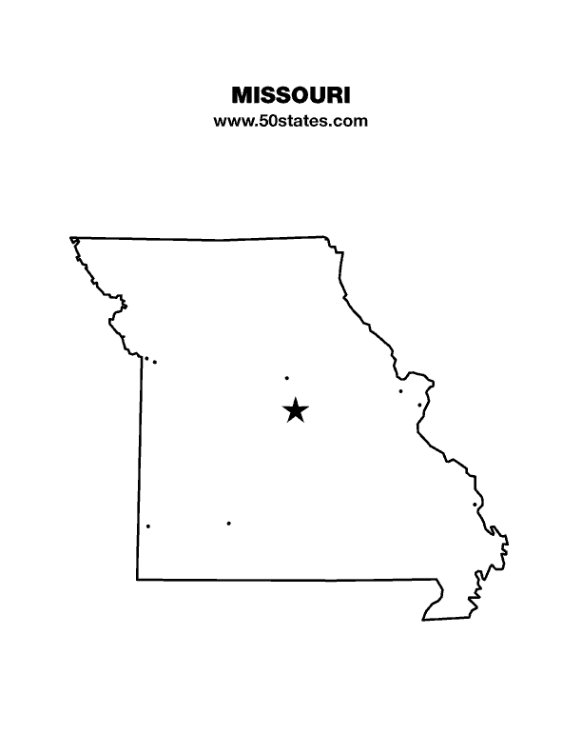
The Blind Missourian
December 2019

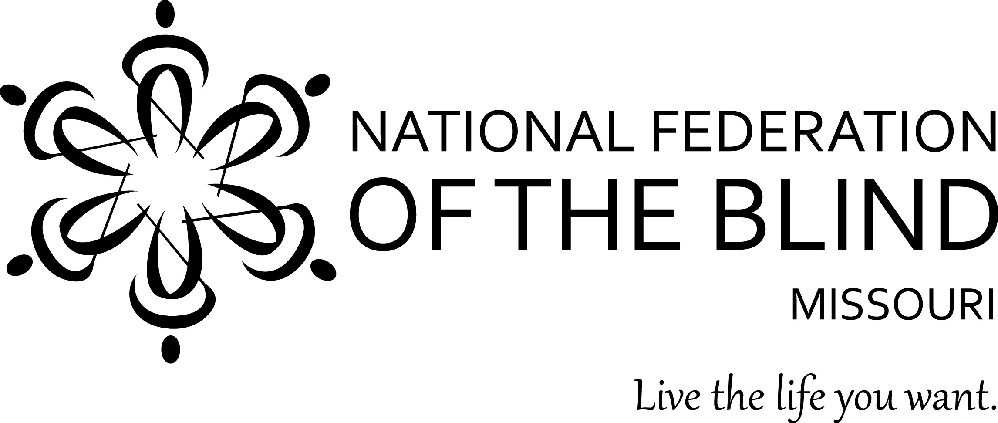

Table of Contents

NFB of Missouri 2020 Convention Information 1

National Federation of the Blind of Missouri
2020 Scholarship Program 5

It Is Not Trivial by Eugene Coulter 6

A Lady, a Scholar, and a Beloved Friend:
Patricia Morrow’s Obituary 7

Roses and Raspberries 8

Important Dates 11

One Minute Message

The National Federation of the Blind knows that blindness is not the characteristic that defines you or your future. Every day we raise the expectations of blind people, because low expectations create obstacles between blind people and our dreams. You can live the life you want; blindness is not what holds you back.

Pledge of the
National Federation of the Blind

I pledge to participate actively in the efforts of the National Federation of the Blind to achieve equality, opportunity, and security for the blind; to support the policies and programs of the Federation; and to abide by its Constitution.
58th Annual Convention National Federation of the Blind of Missouri
Holiday Inn Downtown Convention Center 811 North 9th Street St. Louis, Missouri 314-421-4000
March 26-29, 2020
Pre-register online at www.NFBMo.org

The Lewis and Clark Chapter would like to welcome you to one of the oldest cities west of the Mississippi. St. Louis was settled in 1763 as a Fur Trading Post. The delicious ice cream cone was introduced here at the 1904 World’s Fair. Anheuser Busch was founded in 1860.
We are also home to some more recent iconic attractions such as the Gateway Arch, which has a newly remodeled and more inclusive museum. The well-known Union Station has also been revitalized and now has an Aquarium which is expected to open in December of 2019, and there is also a new 200-foot lighted Ferris Wheel. Do not forget our great sports teams. We are proud to be the home of the St. Louis Blues who are the defending Stanley Cup Champions, and our 2019 National League Central Champion Cardinals.
Come to the Holiday Inn Downtown with room rates of $104 a night (plus 16.929 % tax), make reservations by calling the hotel direct. The hotel features a fitness center, indoor swimming pool, guest laundry, and free internet. The St. Louis Sports Hall of Fame Bar and Grill is open for breakfast, lunch, and dinner.
Registration will be open from 8:15 to 8:45 AM Friday and 5:00 PM to 7:00 PM Friday and 8:00 AM to 8:25 AM Saturday. Hospitality will be open on Friday evening from 5:00 to 10:00. Come eat, drink, and enjoy the fellowship!
All attendees should plan to come to the banquet on Saturday evening which is the highlight of our convention. We will also have a planned lunch for Friday and Saturday and our annual Prayer Breakfast Sunday. Attendees are encouraged to take advantage of these meals as there are not many other restaurant facilities nearby. After March 16 the cost for registration and banquet increases by $5, lunch by $4, and Prayer Breakfast by $3.
We will be offering the Kid’s Zone for children in need of supervised care. There is no cost for children who are registered for the convention. Registration for children fourteen and under is $10.00. This year we are offering children’s pricing for our meals; check the accompanying children’s registration form for all of the details. Important: we must receive requests for child care by March 5.
Exhibit space and convention sponsorships are again available; see the accompanying Exhibit and Sponsorship Form for details. Exhibit and Sponsorship Forms and payment must be received by March 16, 2020.
To donate door prizes, please contact Door Prize Chair Jenny Carmack at Phone: 314-239-9776.
National Federation of the Blind of Missouri
2020 State Convention
Adult Registration Form
Saint Louis, March 26-29, 2020

Please use one form per residence. Several registrations may be combined on one check if they are sent in the same envelope. There are separate forms for child care and exhibitors/sponsors.
Registrant Name: ________________________________________________
Second Registrant: _________________________________
Street Address: __________________________, Apt.: ________
City: ______________________, State: ____, Zip Code: _________
Phone Number: ______________, Email: _____________________
Select preferred agenda format: __ Braille, ___ Print, ___ Electronic
Desired Blind Missourian format: ___Print, ___Email, ___Thumb Drive, __None
Desired Braille Monitor format: ___Print, ___Email, ___Thumb Drive
Select the items or events that you would like to purchase below:
*Convention Registration: Preregistration prior to March 16, 2020
Number of registrants: ___ at $15.00 Total: $______
Annual Banquet: ____ tickets needed at $35.00 Total: $______
Friday Luncheon: ____ tickets needed at $16.00 Total: $______
Saturday Luncheon: ____ tickets needed at $16.00 Total: $______
Prayer Breakfast: ____ tickets needed at $15.00 Total: $______
Total amount enclosed: $______
*For registrations postmarked after March 16, 2020 please adjust amounts as follows: registration - $20.00, lunches - $20.00, banquet - $40.00, and breakfast - $18.00. Add amounts on all forms enclosed and make your check payable to: NFB of Missouri. Please mail to: Carol Coulter, 1504 Furlong Drive, Columbia, MO 65202.
National Federation of the Blind of Missouri Convention
Children’s Registration Form and Kid’s Zone Request
March 26-29, 2020

We will be offering child care in the Kid’s Zone for those children in need of supervised care. There is no additional cost for children who are registered for the convention, see the form below. Care will be provided on Saturday during the morning and afternoon sessions, the evening banquet until 9:00 PM, and the Sunday morning session which will adjourn at 12:00 PM. Meals are not provided in the Kid’s Zone so parents need to make arrangements to feed their children. Important: Parents wanting care for their children must send this request on or before March 5, 2020. Payment for pre-registration and meals also needs to be received by March 5, 2020. You should mail it along with payment to the address below. Payments can be mailed or made at www.nfbmo.org. Meals purchased after March 5, 2019 will cost an additional $3.00 for lunches and $5.00 for banquet.

Name of Parent or Guardian: _____________________
Address: ________________________________________
City, State, Zip: ________________________________
Cell Phone: _______________ Home Phone: ________________
Names and Ages of Children: ________________________________________
__________________________________________________________________Special Concerns: __________________________________________________________________Number of registrants: ___ at $10.00 Total: $______
Annual Banquet: ____ tickets needed at $20.00 Total: $______
Friday Luncheon: ____ tickets needed at $10.00 Total: $______
Saturday Luncheon: ____ tickets needed at $10.00 Total: $______
Prayer Breakfast: ____ tickets needed at $15.00 Total: $______
Total amount enclosed: $______
Mail form and Check made payable to NFB of Missouri to: Carol Coulter, Treasurer, 1504 Furlong Drive; Columbia MO 65202.
National Federation of the Blind of Missouri Convention
Sponsorship and Exhibitor Registration March 27, 2020

We are pleased to offer the opportunity for companies and organizations to either exhibit or sponsor our 2020 convention. This year we will be at the Holiday Inn Downtown, 811 N. 9th, St. Louis from March 27-29. Exhibits will be open on Friday, March 27 from 2:00 PM to 10:00 PM. Below is the registration form including information on sponsorships.

Name of Organization: _____________________ Phone: __________________

Address: _____________________________________________

Items exhibiting: ___________________ Email: ___________________

Exhibits:
____ $35 for exhibit table only
____ fee waved for NFB Chapters exhibiting

Sponsorships:
____ Bronze $100, includes exhibit table and 25-word informational message in the agenda.
____ Silver $250, includes exhibit table, 50-word informational message in the agenda, and thank you at opening ceremony and banquet.
____ Gold $500, includes exhibit table 50-word informational message in the agenda, presentation on the agenda, and thank you at opening ceremony and banquet.
____Diamond $1,000, same as Gold but also includes two free banquet tickets.

Make checks payable to NFB of Missouri and mail to: Carol Coulter, Treasurer 1504 Furlong Drive Columbia, MO 65202

National Federation of the Blind of Missouri
2020 Scholarship Program

The National Federation of the Blind of Missouri announces our 2020 Scholarship Program. We will be accepting applications until February 1, 2020. We invite all qualified candidates to apply. Applicants must be legally blind and plan to enroll in a post-secondary institution for the fall of 2020. Applicants should live in Missouri but need not be a member of the National Federation of the Blind. Scholarships begin at $500 and are based on merit. We invite applicants to submit all information and documents online. All application materials must be received by February 1, 2020, either through the online form (found at www.nfbmo.org) or at the email address provided below. Acknowledgment of applications and documents will be sent upon receipt. If you have questions or concerns, please do not hesitate to contact the Scholarship Chair.
A complete application consists of the official application form and a student essay, plus these supporting documents: student transcripts, two letters of recommendation, a letter from an NFB of Missouri Scholarship Committee member, and proof of legal blindness. Please note that letters of recommendation must not be submitted by the applicant, but must come directly from the person authoring the recommendation.
In an effective essay the applicant may consider sharing about his or her life in a way that gives the committee insight into him or her. The essay should cover the ways in which one lives successfully as a blind person and describe personal goals for the future. Committee members give the essay a great deal of attention.
In addition to receiving the monetary award, the scholarship recipients will attend the convention of the National Federation of the Blind of Missouri, March 27-29, 2020, at the Holiday Inn Downtown, St. Louis, MO. Hotel accommodations, convention registration, and planned meals during the convention will be included. We are also happy to help coordinate transportation to ensure this is not a barrier to our scholarship class. The type of transportation assistance may vary based on where in Missouri the winner resides and the available transportation resources in that community.
Throughout the convention, scholarship winners will have an opportunity to learn about the National Federation of the Blind and network with successful blind people. In addition, final interviews with the Scholarship Committee will aid the committee in determining the scholarship each winner will receive.
You should know that merit scholarships from the National Federation of the Blind go directly to the winner and should not be considered as a similar benefit by Rehabilitation Services for the Blind. Therefore, students can use funds to meet expenses that other funding sources do not cover. Also, merit scholarships are viewed favorably when included on a resume.
The application can be found on the NFB of Missouri website. If you have any questions about the application process, please contact the scholarship chair.

Robin House, Chair
Scholarship Committee
National Federation of the Blind of Missouri
Phone: 314-265-6852.
Email: scholarships@nfbmo.org
Web Page: www.nfbmo.org

It Is Not Trivial
By Eugene Coulter

There is an old saying that the squeaky wheel gets the grease and the activities of the Columbia Chapter in the last few months proves that message to be true. In August we invited a member of the Columbia City Council and a public works engineer at our meeting to discuss pedestrian accessibility.
Among the issues we spoke with them about were tree limbs overhanging sidewalks, cars and scooters blocking sidewalks, torn up and buckled concrete, and guy wires that stuck out over the walkway. We also requested that the city look into audible traffic signals at four troublesome intersections. The officials took notes and told us ways to get action on these issues. We thought that they seemed to listen and actually care about what we said. Within a few weeks the city had taken action on several of our specific examples. They fixed a sidewalk issue, moved a guy wire, and had property owners cut back over-hanging limbs and bushes. The process is underway to install the first audible signal which should appear in 2020 as it takes a while to get an improvement like that done.
As we were meeting with city officials, we were also preparing for our ninth annual trivia night on November 2 at the local Masonic Lodge. We received great support from the community, and the Masons have invited us back to tentatively hold our tenth annual trivia night on November 14, 2020. Our attendance was very good considering the number of people who were unable to join us due to illness. We sold a lot of chili and hotdogs which were the perfect foods for the cool weather. In addition to the eight rounds of trivia questions, we had three side games, a 50/50 drawing, and a basket drawing. It would not have been a trivia night unless the audience disagreed with one of the answers to a question. The question was, “Where was Walt Disney born?” The answer, of course, is Chicago, but audience members were sure he was born in Marceline, Missouri. We had to point out that while he grew up in Marceline he was actually born in Chicago. We hope to see some of you reading this, at trivia night next year!
Speaking of fund raising, the Columbia Chapter will be selling re-usable telescoping metal straws and collapsible fans over the next six months. The straws are designed to replace plastic straws and therefore are environmentally friendly, and, of course, the fans will keep you cool even in the most heated discussion. We of the Columbia Chapter wish everyone the merriest of holiday seasons and may 2020 be prosperous for you and yours!

A Lady, a Scholar, and a Beloved Friend:
Patricia Morrow’s Obituary

Patricia Julian Morrow, aged 86, died on October 30, 2019 in Columbia, surrounded by family members. Her many friends knew her as Pat.
Patricia was born at home in Garfield County, Colorado, on September 23, 1933, to Sylvan Patton and Jean Roe Patton. It was soon discovered she had congenital cataracts which impaired her vision. In spite of this challenge, she excelled in scholarship, graduating from the University of Denver with a B.A. in Humanities, the University of Colorado with an M.A. in English Literature, and completed her Ph.D. at the University of Missouri in 1972. She earned a Fulbright Scholarship and studied in Belgium. Pat always emphasized that blindness is not the characteristic that defines you or your future.
Pat taught English Literature at the University of Missouri at Rolla from 1969 to 1984, when she retired due to illness. Her eyesight continued to fail, yet she was able to edit dissertations and professional journal articles, as well as articles for The Blind Missourian magazine. She never split an infinitive, dangled a participle, or spliced a comma!
She volunteered with the National Federation of the Blind of Missouri and served as the chair for the Scholarship Committee. She found great joy in mentoring blind students who were preparing to attend college. As her vision dimmed, she learned to read in Braille.
Pat was a decades-long member of the Unitarian Universalist Church of Columbia, where she found a true sense of community. The Church sustained her commitment to social justice. She was a fearless kitchen volunteer, serving coffee and gluten-free cookies. If the Church needed three dozen hard-boiled eggs for the homeless shelter, she made them and delivered them by taxi. She loved to recite the lyrics of a parody song called “I Am the Very Model of a Modern Unitarian” with apologies to Gilbert and Sullivan.
In 2003, Pat married Dr. Robert W. Habenstein, a retired Sociology professor. Bob came with a large art collection, a great sense of humor, and three daughters, sons-in-law and grandchildren, an instant family. Pat and Bob enjoyed traveling, jazz music and sharing biographical stories.
Pat is survived by her sisters, Sherri Patton of Pahoa, Hawaii, and Helen Truscott of Pueblo, Colorado, and brother David Patton. She is also survived by her step-daughters, Kay Habenstein Lancaster, Nancy Habenstein Swanson, and Roberta Habenstein Olson, and several grandkids, nieces and nephews. She will be missed by her many friends at Tiger Place, especially Warren and her kind assistant, Debbie Green.
Her ashes will be scattered in the garden at the Unitarian Universalist Church in the near future.
Memorial donations may be sent in Pat’s name to NFB of Missouri, 1504 Furlong Dr., Columbia, MO 65202 or to the Unitarian Church, 2615 Shepard Blvd., Columbia, MO 65201

Roses and Raspberries

Roses and Raspberries is a column that Patricia would often include in her issues of The Blind Missourian when she was the editor. It would contain announcements about graduations, jobs, chapter events, births, deaths, etc. In honor of Patricia’s memory, I decided to entitle this compilation of memories and announcements with this title.

“My stepmother Patricia Julian Morrow, age 86, died late last night. We were with her. Charles read from the Book of Common Prayer. A memorial/scattering of her ashes will be arranged in the near future. Her ashes will be scattered in the garden behind the Unitarian Church on Shepard Blvd in Columbia where she was a member for decades.” - Kay Habenstein Lancaster

“I have known Patricia for many years and can honestly say I have met very few people who were as kind and genuine as she was. Patricia was always asking how you and your family were doing. The only complaining, or should I say frustration, I heard from her was later in her life when she had to rely on others to get her where she wanted to go or do things for her that she once was able to do for herself. She was a very proud and independent person. I was honored and a bit worried when I took over editing The Blind Missourian from Patricia, but she was very supportive. Patricia this issue is for you, I hope it does you justice. I also had the pleasure of serving on the state Scholarship Committee with Patricia, and I don’t think we have had as many applicants since she stepped down, not that any of the committee chairs haven’t done their best; it just shows how good Patricia was at what she did. Patricia rest in peace and you and your beloved Bob can now share eternal happiness together.”- Carol Coulter

“Those of you who know and love Patricia as Debbie and I do will remember with fondness her caring and ever so giving spirit. She was the first to ask what we needed if she knew that one of us was ill. Many of us remember how honored we were to have someone with a Doctorate in English to edit our newsletter, The Blind Missourian. Being an academic, Patricia was a fine chairman of our Scholarship Committee, and everything she did was performed with gentleness and grace.
The last few years have not been very kind to her, first with the passing of her husband, Bob, and later with ailments that gradually robbed her of the things that meant so much to her. I know that many of you will join Debbie and I in our thankfulness that we knew, loved, and were loved by Patricia.”- Gary Wunder

“Patricia and I served together on the Wolfner Advisory Council for several years. We would oftentimes take her back to Columbia on our way home. We had many wonderful conversations between Jefferson City and Columbia, and I learned so much from her. She was an amazing lady, and I always looked forward to those trips because I knew I would learn something I didn't know before. She will definitely be missed.”- Dennis Miller

“Patricia always loved when the Columbia chapter would come to her house and carol. She gave us cookies and welcomed us into her home. I wish I knew her back when, before I joined the affiliate. She always seemed like a cool person. I'm so sorry she is gone. The Columbia chapter should sing a special carol in her memory this year.”- Julie McGinnity

“We all here in Jefferson City extend our sympathy to our Columbia Chapter for the loss of our Federation friend, Patricia. I feel very sad as we have lost a wonderful friend. Just a day or so before she passed, I had been thinking about her a lot and wishing I could have visited her. We all agree that she was the most anxious to please and help when at all possible. I truly feel an absence there now as she was a very special friend.”- Rita Lynch
“I am very sorry to hear of her passing. She was always a very sweet, kind, and smart woman. I remember the last time we sang Christmas Carols to her; she invited us in and gave us cookies. She was very sweet and made my evening. She will be remembered and missed.”- Dacia Cole

“She was a special lady and will be missed. Even when I saw her last, about a year ago, she came to a meeting and wanted to contribute and participate. Her determination and efforts were admirable. Her legacy to the Columbia Chapter is an outstanding one for sure.”- Cheryl Meister
“I am so sorry to hear about Patricia Morrow's passing away. She was quite a wonderful lady who included everyone. She was always willing to help and advise. Blessings to her family and friends.”- Ruby Polk

Our Jefferson City Chapter is sad to report the loss of another member. Joyce Bullock passed away at her home here in Jefferson City on October 3rd. Joyce had been a member for three years. Not many Federationists knew her because she was not able to attend many of the Federation activities, but she was proud of being a part of NFB. After retirement, Joyce moved here from Texas and lived with her niece, Sherry Dunket. She had been a member of our Texas Affiliate prior to her move. Joyce managed a cafeteria there in Texas and was proud to be a part of the Randolph Shepherd Program. She was buried back there in Texas in a family plot. We were told that shortly before she died, she took her oxygen off and said she would not need that anymore. Her last words were thanking God over and over for all the blessings she received. She is now rejoicing in her heavenly home.

Ben and Therese Vercellone are the proud parents of a little girl who was
born on October 17th weighing 8 pounds 13 ounces and is 20 and a half inches long. Her name is Meekyung Lee Vercellone. Meekyung means beautiful and bright in Korean.

The 2020 National Convention of the National Federation of the Blind will be held July 14-19 in Houston, Texas. While the convention was originally planned for two weeks earlier, the Federation agreed to move its convention to accommodate activities in the city of Houston. We believe this change will further enhance the program, exhibits, and dynamic content provided at America's civil rights and resource convention of blind people and their families. More information regarding convention arrangements will be published in the December issue of the Braille Monitor.

The Braille Readers Are Leaders Contest is a fun incentive to sharpen your Braille reading skills. Both research and personal experiences of our members supports the value of Braille literacy. While we promote all types of tools that give us access to more information, none replace or equal what Braille can do for you. Braille is not difficult to learn, but it does require practice and reading to grasp the many ways it can help enrich the lives of blind people. This is why the National Federation of the Blind of Missouri shares this announcement with blind and visually impaired youth and adults in Missouri who are interested in learning Braille and/or increasing your Braille reading speed.
As part of its mission to promote Braille reading, the American Action Fund for Blind Children and Adults is sponsoring Braille Readers Are Leaders 2019-2020. Braille readers in grades K-12 compete with others in their grade category to read the most pages during the reading period from December 1 to January 18. An adult category allows adults who want to practice their Braille skills to participate as well. Registration began on November 1, and it will remain open until the final day of the reading period. Cash prizes will be awarded to the top readers in each category, and each participant will receive a packet of Braille-related gifts.
A little competition is a great way to get kids (and adults!) reading. Please register and start gathering books and magazines to be ready for the reading period to begin. Braille readers are leaders!
You can find the registration form, reading log form, and contest rules by visiting https://actionfund.org/BRAL. If you have questions, email braillereadingcontest@actionfund.org or call 410-659-9315.

Important Dates

Below is a list of important dates for affiliate members over the next few months. Please pay close attention to state convention hotel and pre-registration dates.

January 25 NFB of MO state board meeting in Jefferson City.
February 1 Applications due for National Federation of the Blind of Missouri
Scholarships.
February 10-13 Washington Seminar.
February 14 Last day to make hotel reservations for state convention and be
guaranteed a specific room type e.g. king or two queen beds.
February17-18 Jefferson City Seminar.
February 26 Deadline to apply for Rittgers Stipend to help first-timers come to
convention.
March 5 Deadline for convention child care registration and for children’s pre-
registration and advanced meal pricing.
March 5 Last day to make hotel reservations for state convention.
March 11 All donated funds must be received from chapters by the state treasurer
to be counted for the Roy Zuvers Travelling Trophy.
March 12 Sponsorship/exhibit reservations and payments due.
March 12 State Convention deadline to preregister and get advanced meal pricing
for adults.
March 26-29 58th annual state convention in St. Louis.
April 13 Deadline for divisions to submit dues and membership rosters.

Board of Directors
National Federation of the Blind of Missouri

Officers:
Shelia Wright, President Melissa Kane, First Vice President
Jenny Carmack, Second Vice President Becky Boyer, Recording Secretary
Daniel Garcia, Corresponding Secretary Carol Coulter, Treasurer

Board Members:
Eugene Coulter Roger Crome Robin House
Amy Wilson Chris Tisdal Dacia Cole
Jeff Giffen President Emeritus, Gary Wunder

Chapter Presidents
Columbia Chapter, Eugene Coulter, 573-474-3226
Old Drum Chapter, Amy Wilson, 660-441-1907
Jefferson City Chapter, Melissa Kane, 573-473-8584
Springfield Chapter, Ben Vercellone, 417-755-5285
Kansas City Chapter, Daniel Garcia, 816-505-5520
Lewis and Clark Chapter, Chris Tisdal, 314-440-1684
Mineral Area Chapter, Roger Crome, 573-701-8409
Show-Me State Chapter, Dan Keller, 417-667-6208

Blind Missourian Editor Carol Coulter
Proof Readers Helen Stevens, Shelia Wright, and Gary Wunder
Read by Elisabeth Coulter

FREE MATTER FOR THE

BLIND AND PHYSICALLY

HANDICAPPED

NFB of Missouri
1504 Furlong Dr.
Columbia, MO 65202

